**Govern data across an enterprise**

<https://learn.microsoft.com/en-us/training/paths/govern-data-across-enterprise/>

As the volume and variety of data increases, the challenges of effective data governance will only grow more difficult. Digital transformation technologies have resulted in an explosion of new data sources. How do users know what data is available? How do administrators manage data when they may not know what type of data exists and where it's stored? Does the data contain sensitive or personal information?

All these questions are typically not easy to answer without insights into the data and the source of storage. Before you can develop solid data-governance plans for storage and usage, it's important to have a good idea of the data your organization uses.

[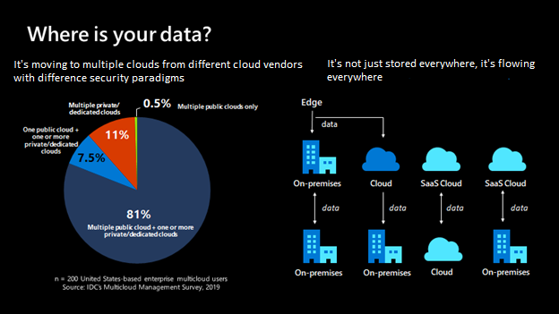](https://learn.microsoft.com/en-us/training/modules/intro-to-microsoft-purview/media/where-is-data-expanded.png#lightbox)

## Example scenario

Suppose you're a data consumer or producer of data. You may be a business or technical data analyst, data scientist, or data engineer. You likely spend significant time on manual processes to annotate, catalog, and find trusted data sources.

Because there's no central location to register data sources, users might be unaware of a data source unless they come into contact with it as part of another process.

Annotating data sources with descriptive metadata is often a lost effort. Client applications typically ignore descriptions that are stored in the data source. Creating documentation for data sources can be difficult, and it's an ongoing responsibility to keep documentation in sync with data sources. Users might not trust documentation that's perceived as being out of date.

Not having an end-to-end data lineage across the data estate leads to data consumers spending a lot of time tracing root-cause problems created by upstream data pipelines that other teams own. Further, data producers make changes to their dataset and inadvertently impact downstream reports that are business or mission critical.

Microsoft Purview is designed to address these issues and to help enterprises get the most value from their existing information assets. The catalog makes data sources easily discoverable and understandable by the users who manage the data.

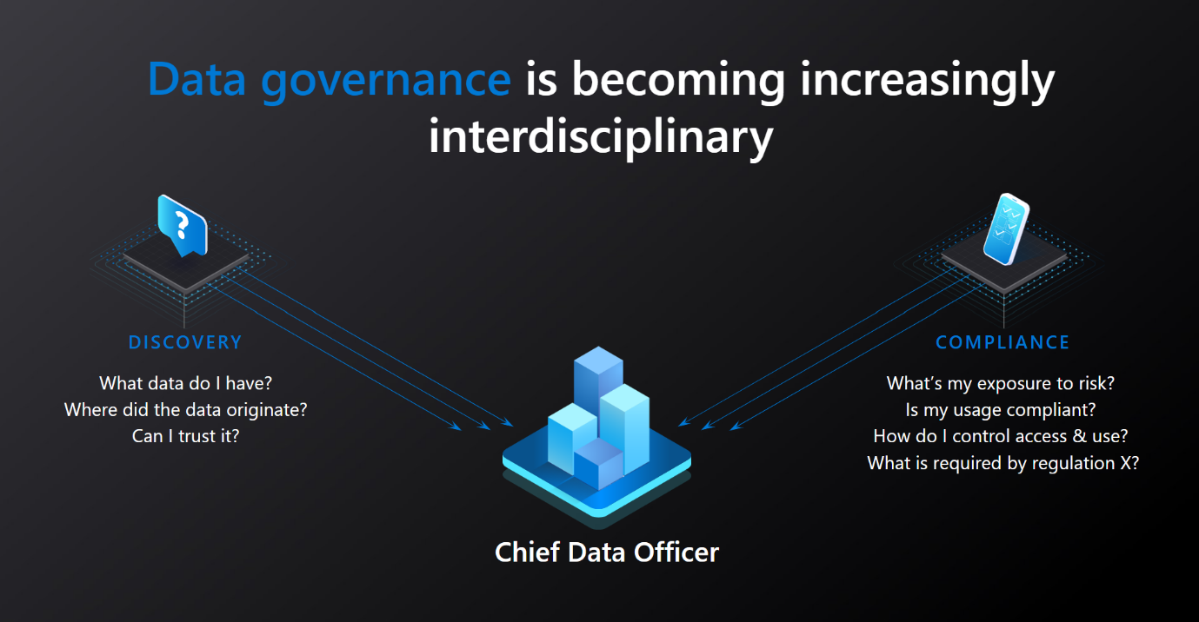

## What will we be doing?

We'll get a high-level overview of Microsoft Purview and discover the key aspects that make it the tool of choice for mapping out your enterprise data. We'll learn how it can help you:

* Manage and govern your data across various platforms and locations.
* Map out your data landscape.
* Classify sensitive data.
* Empower customers to find trustworthy data.

## What is the main goal?

By the end of this session, you'll be able to decide if Microsoft Purview is the right choice to help you manage your enterprise data environment and get a handle on your various data sources.

## What's Microsoft Purview?

Microsoft Purview is a unified data-governance service that helps you manage and govern your on-premises, multicloud, and software-as-a-service (SaaS) data. You can easily create a holistic, up-to-date map of your data landscape with automated data discovery, sensitive data classification, and end-to-end data lineage. You can also empower data consumers to find valuable, trustworthy data.

The main elements are the Microsoft Purview Data Map, Purview Data Catalog, and Purview Data Estate Insights. Microsoft Purview Data Map powers the Purview Data Catalog and Purview Data Estate Insights as unified experiences within the Microsoft Purview governance portal.

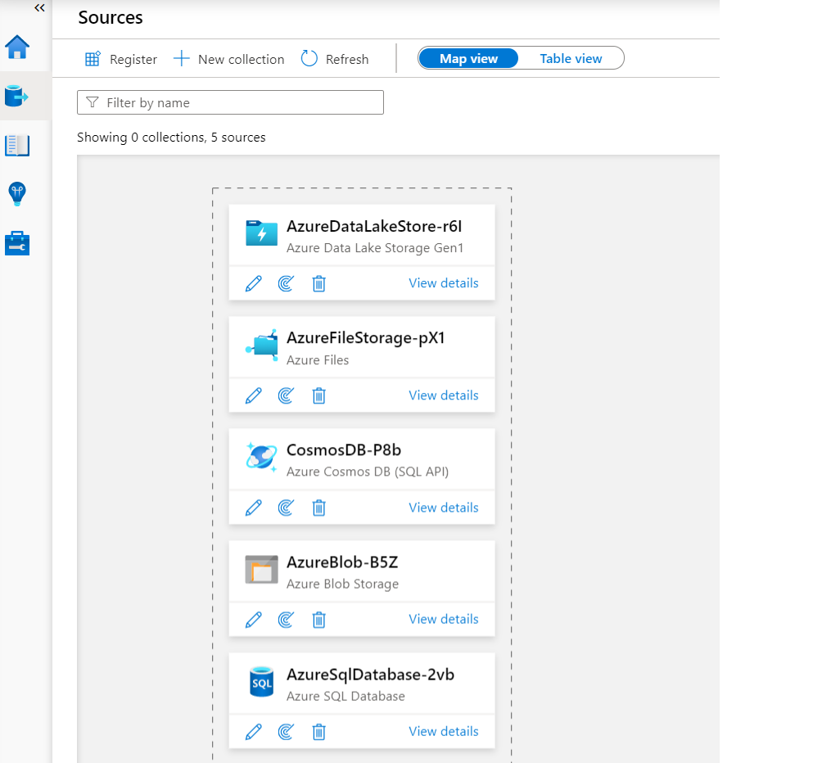

Data Estate Insights, one of the key pillars of Microsoft Purview, offers a bird's-eye view into your data catalog, covering these key facets:

* **Asset insights**: A report on the data estate and source-type distribution. You can view by source type, classification, and file size. View the insights as a graph or key performance indicators (KPI).
* **Scan insights**: This report provides information on the health of your scans (successes, failures, or canceled).
* **Glossary insights**: A status report on the glossary to help users understand the distribution of glossary terms by status, or to view how the terms are attached to assets.
* **Classification insights**: A report showing where classified data is located. It allows security administrators to understand the types of information found in their organization's data estate.
* **Sensitivity insights**: This report focuses on sensitivity labels that are found during scans. Security administrators can make use of this information to ensure security is appropriate for the data estate.
* **File extension insights**: Detailed reporting on file extensions or file types found during scans. You can use this to understand the number of files of each type that exist. It also indicates where these files are located and if they can be scanned for sensitive information.

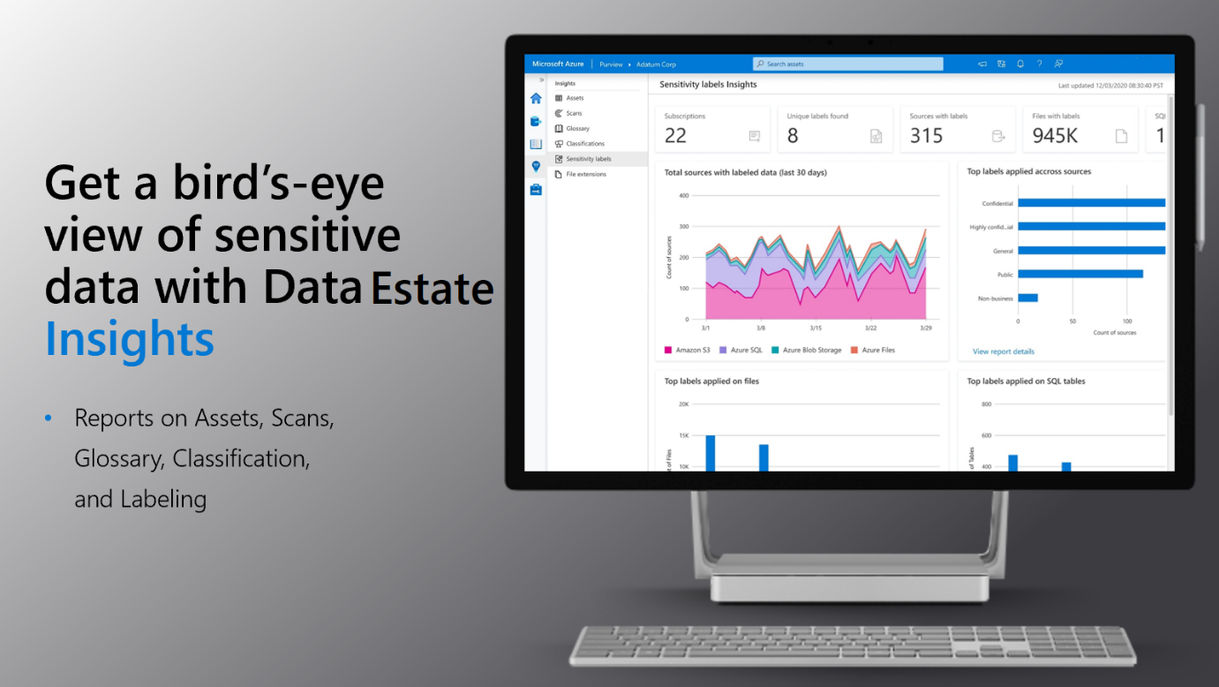

## Microsoft Purview definition

Microsoft Purview is a data-governance solution. It helps customers gain deep knowledge of all their data while maintaining control over its use. With Microsoft Purview, organizations can discover and curate data. They gain insights into their data estate, and centrally govern access to data.

Microsoft Purview is designed to help enterprises get the most value from their existing information assets. It's a cloud-based service where you can register your various data sources with Microsoft Purview. Registering your data in Microsoft Purview helps you discover and understand data sources. Your data sources remain in place, but a copy of the metadata for the source is added to Microsoft Purview. The following image displays some of the data sources supported by Microsoft Purview:

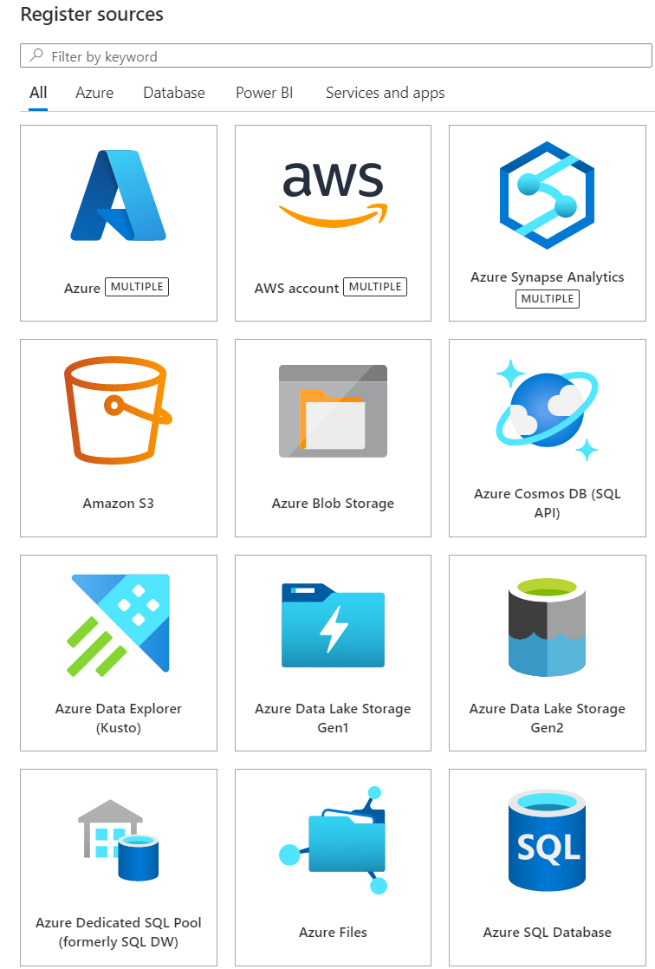

# How Microsoft Purview works

Here's where we'll take a look at how Microsoft Purview works, behind the scenes. You'll learn the core operational theory behind the functioning of Microsoft Purview for mapping and scanning your data sources. The key areas we'll focus on include:

* Loading data in the Data Map
* Browse and search information

## Loading data in the Data Map

The Purview Data Map is a unified map of your data assets and their relationships that enables more effective governance for your data estate. It's a knowledge graph that's the underpinning for the Purview Data Catalog and all the features that it has to offer. It's scalable and robust to meet your enterprise-compliance requirements.

### Sourcing data

Sourcing your data starts with a process where you register data sources. Microsoft Purview supports an array of data sources that span on-premises, multicloud, and software-as-a-service (SaaS) options. You'll register the various data sources so Microsoft Purview is aware of them. The data remains in its location and isn't migrated to any other platform.

You'll register a data source from within the Azure portal. Once you have a Microsoft Purview service configured in Azure, you'll use the Microsoft Purview governance portal to register your data sources.

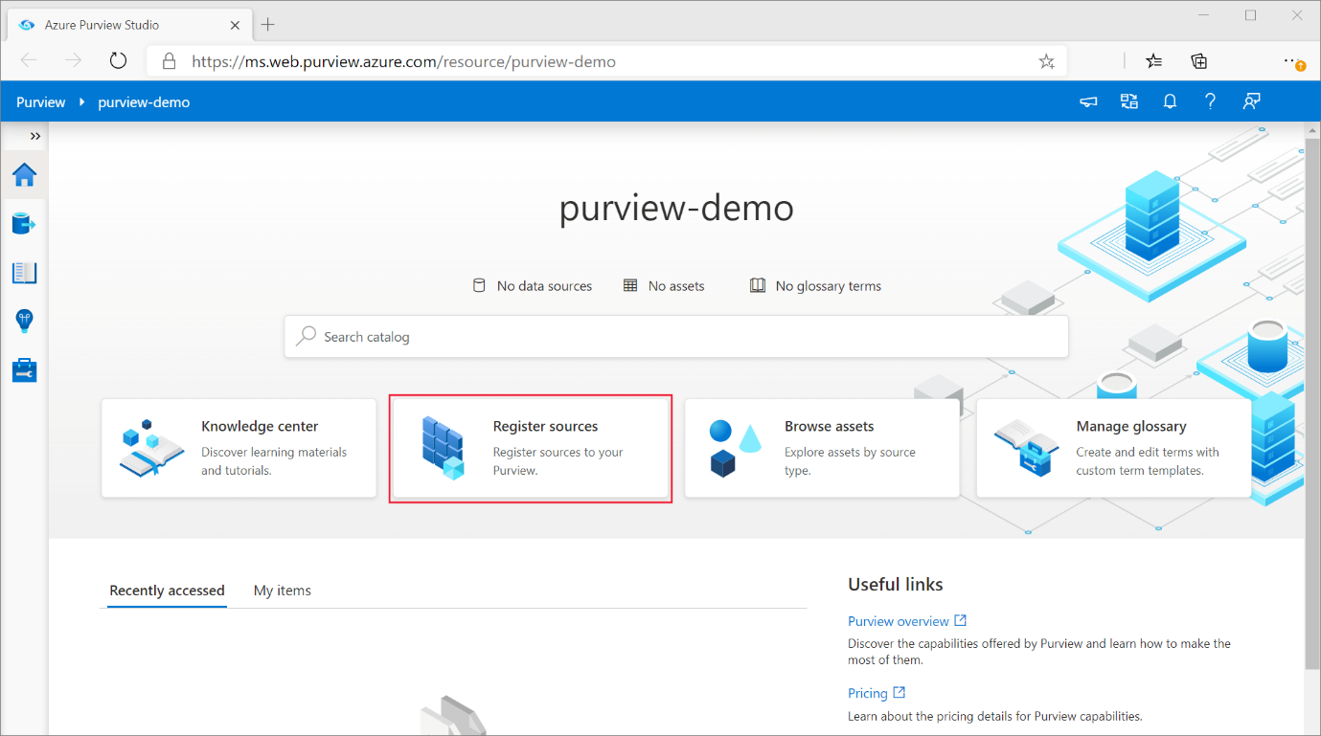

Each type of data source you choose will require specific information to complete the registration. For example, if your data sources reside in your Azure subscription, you'll choose the necessary subscription and storage account name. The following image is an example of choosing an Azure Blob Storage source:

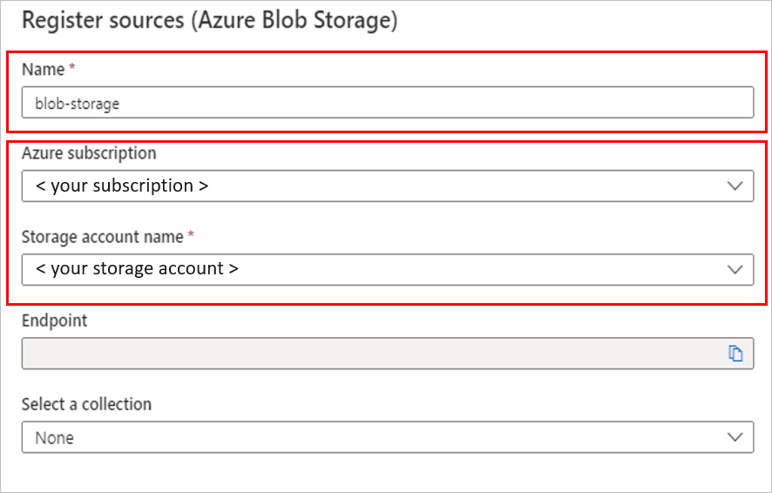

Each data source will have specific requirements for authenticating and configuration to permit scanning of the assets in that data source. If you have data stored in an Amazon S3 standard bucket, you'll need to provide a configuration for the connection. For this service, you'll use Purview to provide a Microsoft account with secure access to AWS, where the Purview scanner will run. The Purview scanner uses this access to your Amazon S3 buckets to read your data, then reports the scanning results (including only the metadata and classification) back to Azure. You can use the Purview classification and labeling reports to analyze and review your data scan results.

**Note**

Check the [**Microsoft Purview connector for Amazon S3 documentation**](https://learn.microsoft.com/en-us/azure/purview/register-scan-amazon-s3) for region support related to AWS S3 sources.

In Microsoft Purview, there are a few options to use for authentication when the service needs to scan data sources. Some of these options are:

* Microsoft Purview Managed Identity
* Account Key (using Key Vault)
* SQL Authentication (using Key Vault)
* Service Principal (using Key Vault)

### Mapping data

A data map is the foundational platform for Microsoft Purview. Data Map = Data assets + Lineage + Classifications + Business Context. Customers create a knowledge graph of data coming in from a range of sources. Purview makes it easy to register and automatically scan and classify data at scale. Within the data map, you can identify the type of data source, along with other details around security, scanning, and so on. The data map allows you to use collections as well.

Collections are a way of grouping data assets into logical categories (collections) to simplify management and discovery of assets within the catalog.

Selecting the Map view displays the data sources in a graphical view, along with the collections you've created for them.

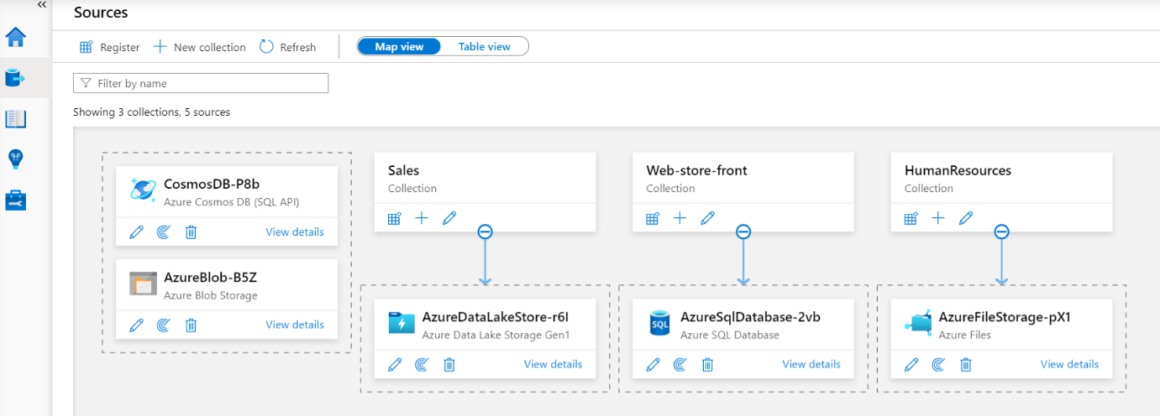

### Scanning data

Once you've registered your data sources, you'll need to run a scan to be able to access the metadata and browse the asset information. You can configure scan rules for the data you want to scan. In a Microsoft Purview catalog, you can create scan rule sets to enable you to quickly scan data sources in your organization.

A scan rule set is a container for grouping a set of scan rules together so that you can easily associate them with a scan. A scan rule set lets you select file types for schema extraction and classification, and also lets you define new custom file types. For example, you might create a default scan rule set for each of your data source types, then use these scan rule sets by default for all scans within your company. You might also want users with the right permissions to create other scan rule sets with different configurations based on business need.

Scanning the data sources will require the entry of credentials for these sources. You can store the credentials in an Azure Key Vault for security and ease of access by your scan rules. The Microsoft Purview governance portal comes with existing system scan rule sets that you can select when creating a new scan rule, or you can specify a custom scan rule set.

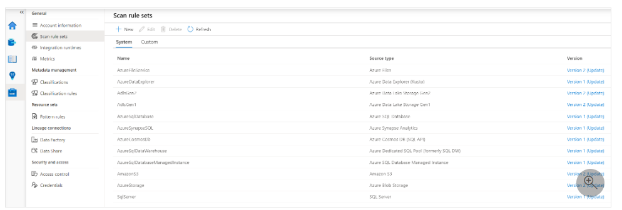

You can also select the file types to include in the scan. The file types will be used in the schema extraction and classification of the data. Built-in file-type support includes:

* CSV
* JSON
* PSV
* SSV
* TSV
* TXT
* XML
* PARQUET
* AVRO
* ORC
* Document file types (.doc, pdf, xls, etc.)

You can select which system and custom classification rules you want to run. The system-classification rules are the same as the sensitive information types in Microsoft 365, which will let you extend your sensitivity-labeling policies in the Microsoft Purview compliance portal to Microsoft Purview supported stores.

### Classification

Metadata is used to help describe the data that is being scanned and made available in the catalog. During the configuration of a scan set, you can specify classification rules to apply during the scan that will also serve as metadata. The classification rules fall under five major categories:

* **Government**: Covers attributes such as government identity cards, driver license numbers, passport numbers, and so on.
* **Financial**: Covers attributes such as bank account numbers or credit card numbers.
* **Personal**: Personal information such as a person's age, date of birth, email address, phone number, and so on.
* **Security**: Attributes like passwords that may be stored.
* **Miscellaneous**: Attributes not covered in the other categories.

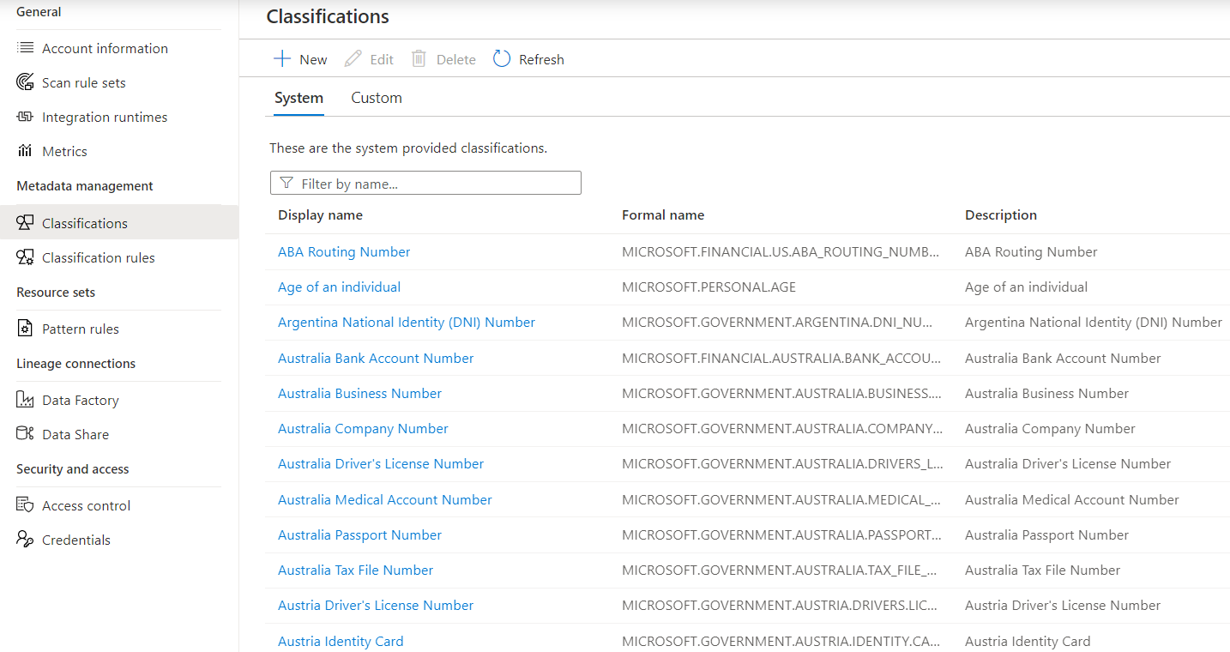

After you register a data source, you can then enrich its metadata. Either the user who registered the data source or another user in the enterprise adds the metadata. Any user can annotate a data source by providing descriptions, tags, or other metadata for requesting data-source access. This descriptive metadata supplements the structural metadata, such as column names and data types, that's registered from the data source.

Discovering and understanding data sources and their use is the primary purpose of registering the sources. Enterprise users might need data for business intelligence, application development, data science, or any other task where the right data is required. They'll use the data catalog discovery experience to quickly find data that matches their needs, understand the data to evaluate its fitness for the purpose, and consume the data by opening the data source in their tool of choice.

At the same time, users can contribute to the catalog by tagging, documenting, and annotating data sources that have already been registered. They can also register new data sources, which are then discovered, understood, and consumed by the community of catalog users.

## Browse and search

Microsoft Purview allows you to search information from Data Map using Purview Catalog. You can perform text-based search and incorporate business context into the search as well.

You can use business context to search information from the Purview catalog. You can define business glossaries (and bulk import existing ones, too) and apply business context onto assets in the Data Map. They can then use this business context to browse and search information from the Data Map.

Enable effortless discovery with:

* Semantic search and browse
* Business glossary and workflows
* Data lineage with sources, owners, transformations, and lifecycle​
* 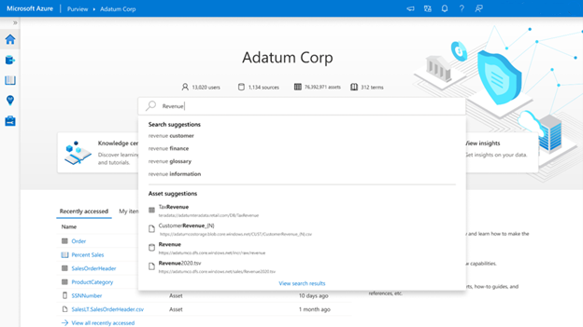

## Data lineage

* The concept of data lineage focuses on the lifecycle of data. The lifecycle concerns itself with the various stages data may go through. Data is sourced, moved, and stored throughout the lifecycle. Data may also undergo transformations in the extract load transform/extract transform load (ELT/ETL) operations.
* Data lineage can offer insights into the data lifecycle by looking at the data pipeline. You can use the lineage to identify the root cause of issues, perform data quality analysis, and verify compliance.
* Microsoft Purview represents this data lineage in a visual form, showing data movement from source to destination.

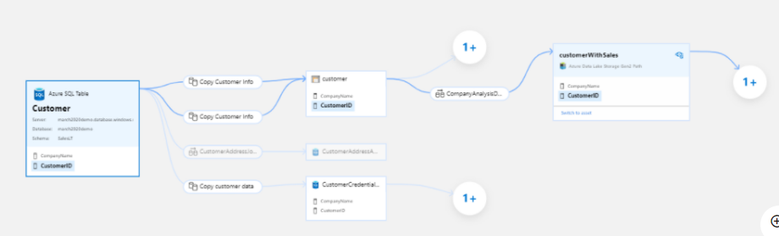

# When to use Microsoft Purview

Here, we'll discuss how you can decide if Microsoft Purview is the right choice for your data-governance and discovery needs. Here are the criteria that indicate whether Microsoft Purview will meet your requirements:

* Discovery
* Governance

## Decision criteria

Let's take a look at the listed criteria and see how Microsoft Purview can help address the needs in those specific areas.

### Discovery

Because there's no central location to register data sources, users might be unaware of a data source unless they come into contact with it as part of another process. The catalog makes data sources easily discoverable and understandable by the users who manage the data.

Unless users know the location of a data source, they can't connect to the data by using a client application. Data-consumption experiences require users to know the connection string or path.

The intended use of the data is hidden to users unless they know the location of a data source's documentation. Data sources and documentation might live in several places and be consumed through different kinds of experiences.

### Governance

As the data in your organization grows, the task of discovering, protecting, and governing that data becomes increasingly difficult. Data is stored in different locations, which may be required for compliance reasons. The data may contain sensitive information such as credit card numbers, social security numbers, or other personal information.

Compliance with company security policies, government regulations, and customer needs are critical considerations for data governance. Understanding which data sources contain sensitive information is key to knowing where protections are needed and how to guard against access to this sensitive data.



## Apply the criteria

Let's take a look at how Microsoft Purview can address the criteria mentioned.

### Does Microsoft Purview help with data discovery?

Do you require a solution or centralized location to register data sources? For the most part, users might be unaware of a data source unless they come into contact with it as part of another process. Microsoft Purview can help to provide a solution.

Once you've registered data sources in the Microsoft Purview governance portal and displayed them in the data map, you can set up scanning of those data sources. The metadata returned helps catalog the data found in those sources, making it easier for users to discover what the data sources contain. The metadata is also indexed to make each data source easily discoverable via search and understandable to the users who discover it.

At the same time, users can contribute to the catalog by tagging, documenting, and annotating data sources that have already been registered. They can also register new data sources, which are then discovered, understood, and consumed by the community of catalog users.

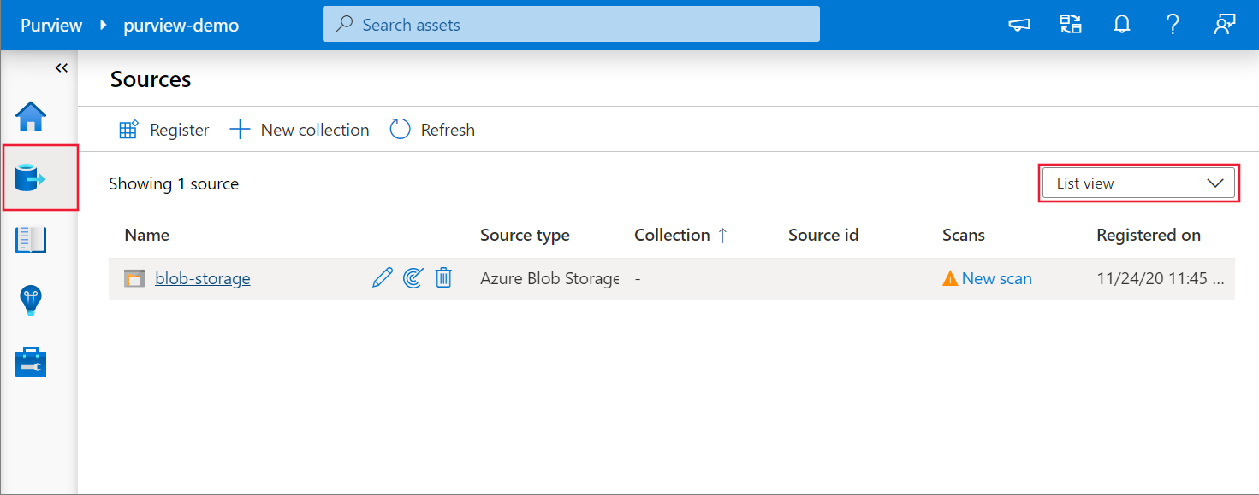

### Does Microsoft Purview help with data governance?

Microsoft Purview can scan and automatically classify documentation files. Microsoft Purview classifies data by RegEx and Bloom Filter. Bloom Filter classifications include attributes for city, country/region, place, and person information. RegEx classifications cover a broad range of attributes that cover categories such as bank information (ABA routing numbers or country/region-specific banking account numbers), passport numbers, country/region-specific identification numbers, and so on. You can find the [full list of supported classifications](https://learn.microsoft.com/en-us/azure/purview/supported-classifications) in the documentation for Microsoft Purview.

Microsoft Purview also uses predefined Data Plane roles to help control who has access to the information in Microsoft Purview. For access, users can only use the Microsoft Purview Account if they're placed in at least one of the supported roles (Data Reader, Data Curator, Data Source Administrator). When a Microsoft Purview Account is created, no one but the creator can access the account or use its APIs until they're put in one or more of the previously defined roles. The roles are:

* **Purview Data Reader Role**: Has access to the Microsoft Purview governance portal and can read all content in Microsoft Purview except for scan bindings.
* **Purview Data Curator Role**: Has access to the Microsoft Purview governance portal and can read all content in Microsoft Purview except for scan bindings. Can edit information about assets, can edit classification definitions and glossary terms, and can apply classifications and glossary terms to assets.
* **Purview Data Source Administrator Role**: Doesn't have access to the Microsoft Purview governance portal (the user needs to also be in the Data Reader or Data Curator roles). Can manage all aspects of scanning data into Microsoft Purview, but doesn't have read or write access to content in Microsoft Purview beyond those tasks related to scanning.

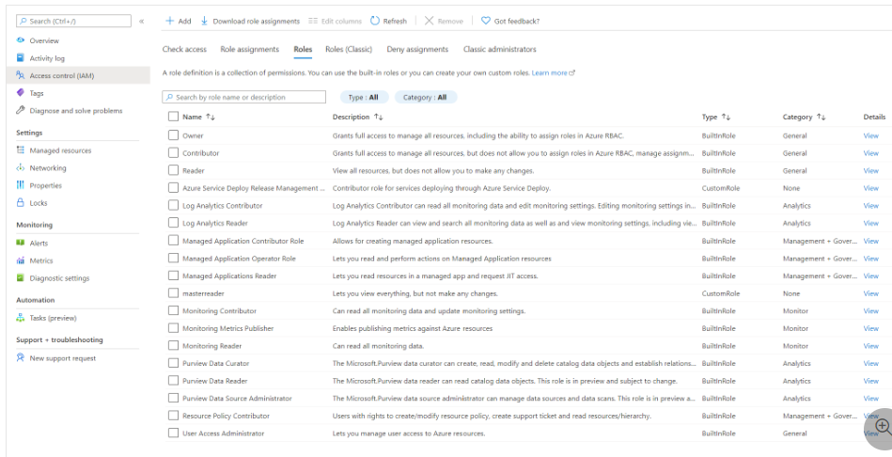

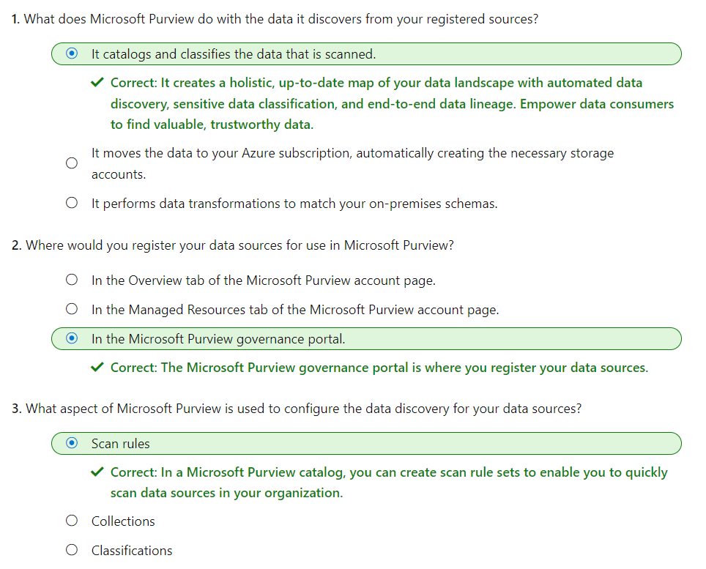

# Discover trusted data using Microsoft Purview

Microsoft Purview is a unified data governance service that helps you manage and govern your on-premises, multi-cloud, and software-as-a-service (SaaS) data. Data professionals can easily create a holistic, up-to-date map of the entire data landscape. Microsoft Purview includes automated data discovery, sensitive data classification, and end-to-end data lineage. Microsoft Purview can empower data analysts and other data consumers to find valuable, trustworthy data.

Imagine that you're a new Data Analyst at Contoso. In your second week, the sales manager desperately asks for the latest inventory and sales data for an impromptu review. After clarifying the requirements, you know you need to quickly find accurate assets to create a report. With the help of Microsoft Purview data catalog, you'll be able to search, browse, and discover assets. More importantly, you'll be able to validate that you’re using the right data sources for your reports.

# Search for assets

Microsoft Purview offers a central place to discover and understand assets to use in your day-to-day activities. This central place, Microsoft Purview data catalog, provides advanced search capabilities to quickly find the right assets and information. Using keywords, business terms and Microsoft Purview data catalog functionalities, you can find the assets needed to build and design reports.

As a data analyst looking for assets, you'll be searching the Microsoft Purview data catalog. This assumes that the Microsoft Purview data Map has been created by your organization. The data map provides the foundation for data discovery. The data map captures metadata about enterprise data in analytics and operations systems on-premises and in the cloud and must be established before the data catalog can be searched.

**Note**

Learn more about the [**Microsoft Purview data map**](https://learn.microsoft.com/en-us/azure/purview/concept-elastic-data-map) components.

## Search the Microsoft Purview data catalog

From the Microsoft Purview Studio home page, users can type relevant keywords to start discovering assets. In this scenario, you're looking for “product sales.”

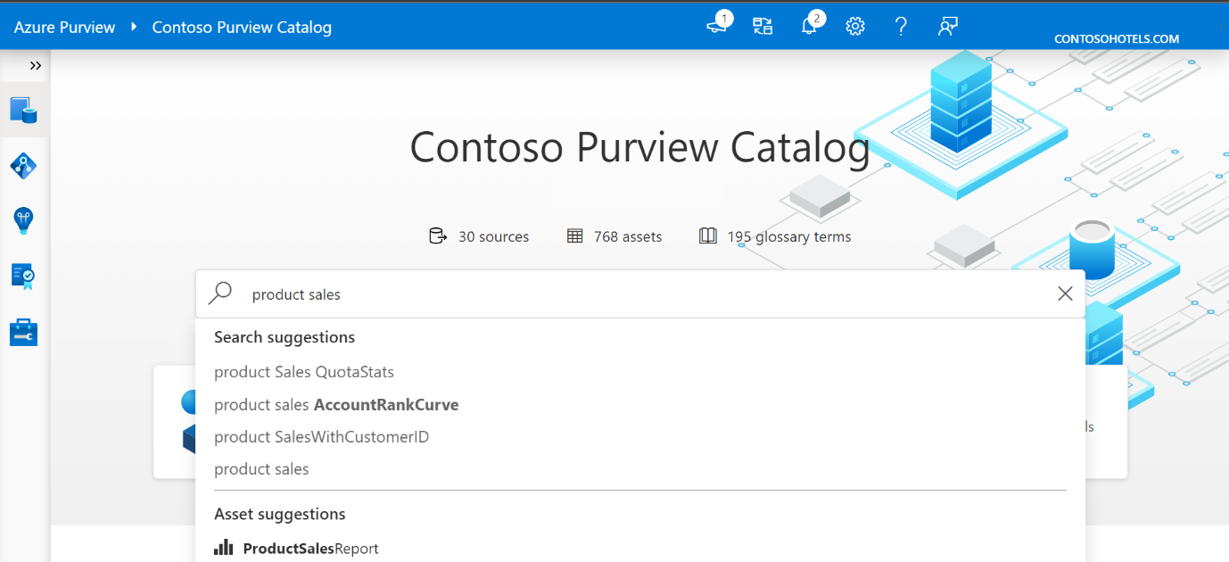

The screenshot below displays the search result, with all assets corresponding to the keywords entered in the search engine.

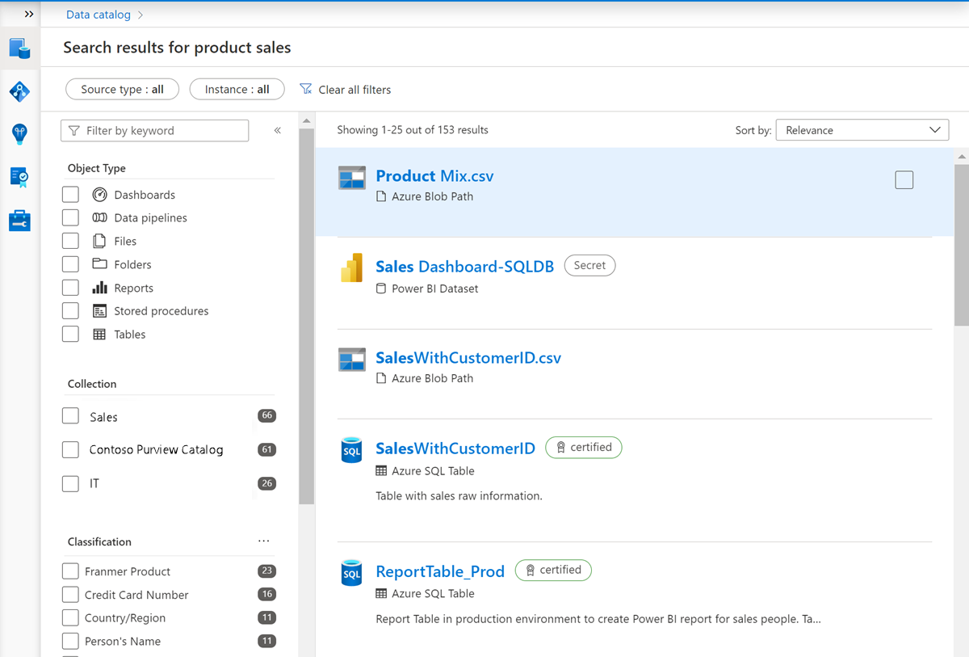

You can fine-tune your search using the filters on the left side of the page.

You can filter by:

* Source type (and instance if needed)
* Object type
* Classification
* Glossary term
* If needed, more options are available like Collection, Contact and Label

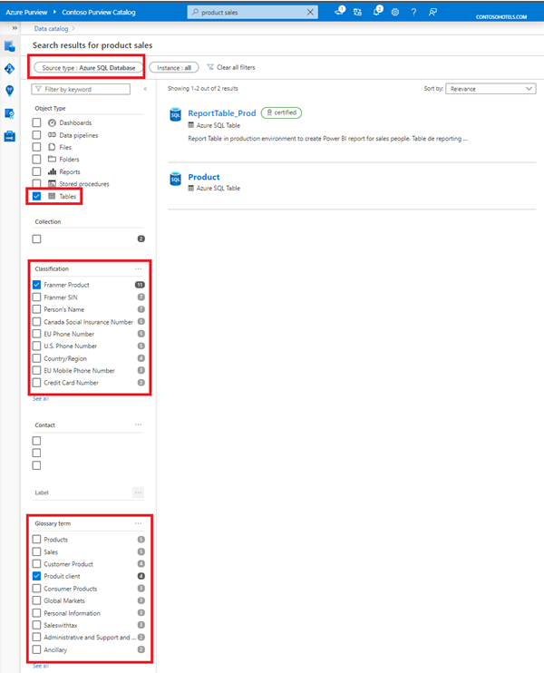

You've been instructed to connect to sources like Azure SQL tables. In the result displayed below, two assets are displayed. To use the correct asset, it’s possible to browse each asset to dig for more detailed information. Alternatively, you can rely on the work done by the data stewards who have labeled certified assets for the organization.

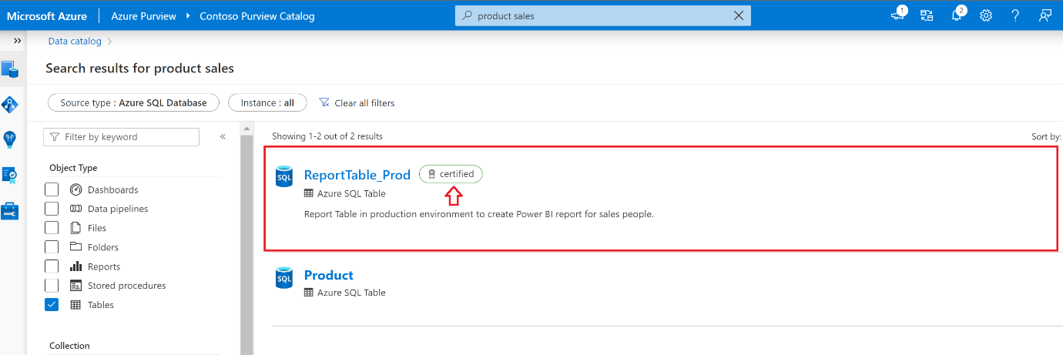

Before using this asset to create your report, you need to verify more details and validate where data comes from to populate this asset. Select the asset to access more information.

## Understand a single asset

### Asset overview

Select an asset to see the overview. The overview displays information at a glance, including a description, asset classification, schema classification, collection path, asset hierarchy, and glossary terms.

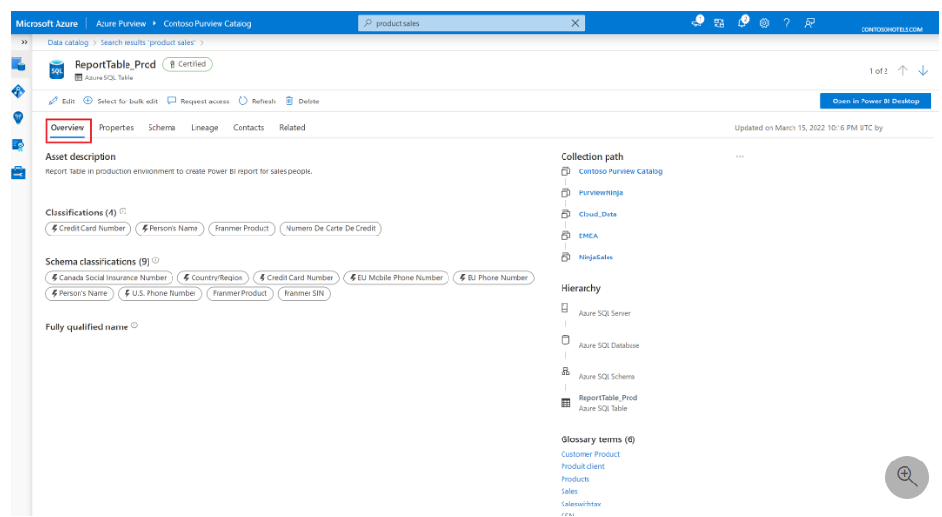

The asset description provides a brief explanation of the purpose of an asset. Data stewards have made data analysts lives easier in the screenshot below, by noting that this is the correct resource to use for sales reporting.

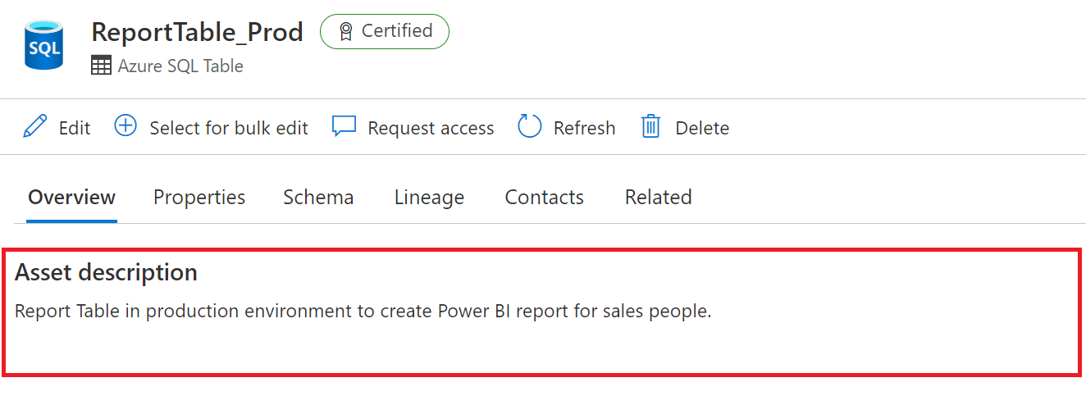

Beneath the description, you'll see the asset classification and schema classification.

Data classification, in the context of Microsoft Purview, is a way of categorizing data assets by assigning unique logical labels or classes. Classification is based on the business context of the data. For example, you might classify assets by Passport Number, Driver's License Number, Credit Card Number, SWIFT Code, Person’s Name, and so on. Asset classifications can be automatically applied during a scan or applied manually.

**Note**

Microsoft Purview comes with more than 200 classifications out of the box. For a full list of classifications, see [**System classifications in Microsoft Purview**](https://learn.microsoft.com/en-us/azure/purview/supported-classifications).

The overview tab reflects both asset level classifications and column level classifications that have been applied, which you can also view as part of the schema.

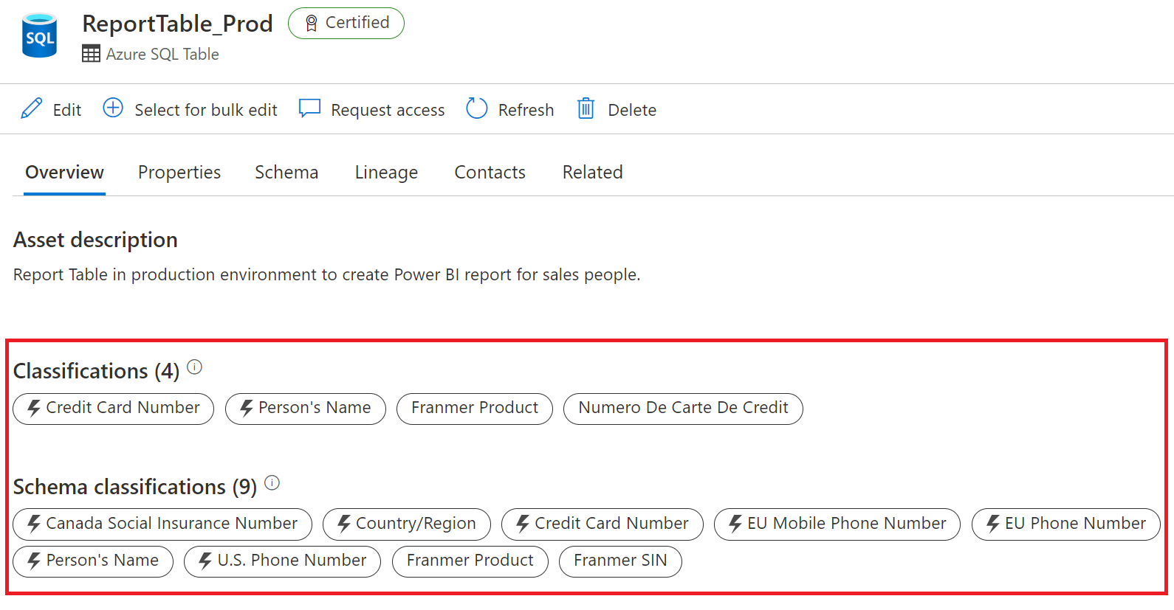

**Important**

You may notice that the classifications displayed above are sensitive or contain personally identifiable information (PII). data encryption is done at the source level, and Microsoft Purview stores only the metadata. It does not preview data.

You can also view the collection path, hierarchy and glossary terms on the right side of the overview tab.

The collection path refers to the location of the asset inside Microsoft Purview. You have the option to move an asset to another collection.

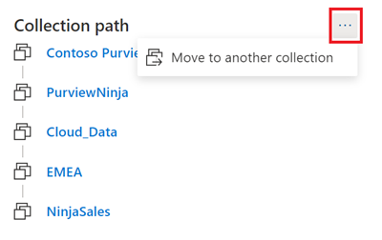

You can view the full asset hierarchy within the overview tab. As an example: if you navigate to a SQL table, then you can see the schema, database, and the server the table belongs to.

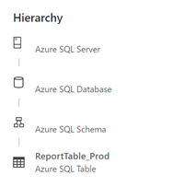

Glossary terms are a managed vocabulary for business terms that can be used to categorize and relate assets across your environment. For example, terms like 'customer,' 'buyer, 'cost center,' or any terms that give your data context for your users. You can view the glossary terms for an asset in the overview section, and you can add a glossary term on an asset by editing the asset.

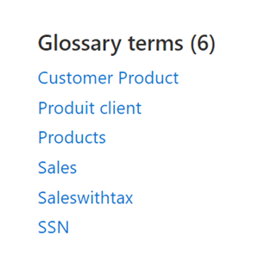

**Note**

For more information, see the [**business glossary page**](https://learn.microsoft.com/en-us/azure/purview/concept-business-glossary).

### Asset schema

The schema view of the asset includes more granular details about the asset, such as column names, data types, column level classifications, terms, and descriptions.

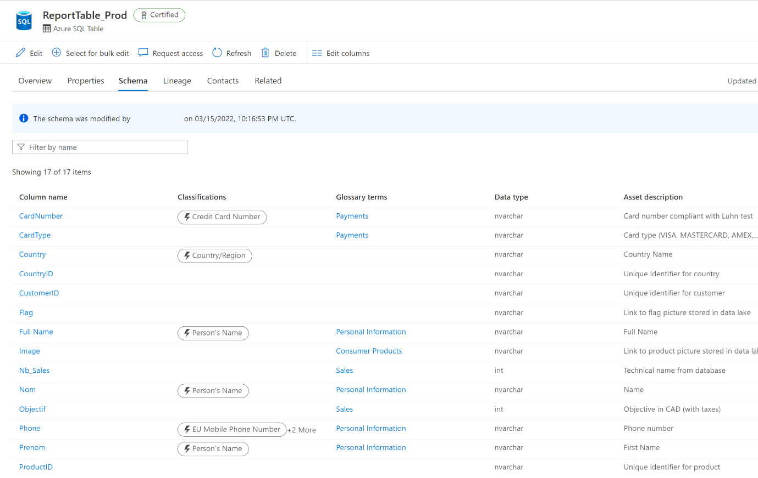

### Asset lineage

Asset lineage gives you a clear view of how the asset is populated and where data comes from. Data lineage is broadly understood as the lifecycle that spans the data's origin, and where it moves over time across the data estate. Data lineage is important to analysts because it enables understanding of where data is coming from, what upstream changes may have occurred, and how it flows through the enterprise data systems.

A single view on the asset lineage tab displays the data flow to and from the asset. Asset lineage can also help you understand how the asset was built and how the asset is used inside the organization.

The columns pane on the left side of the lineage tab allows users to select and track columns as they flow through the lineage. For example, if you select the column Full Name, you can see how the Full Name field was created and where the information comes from.

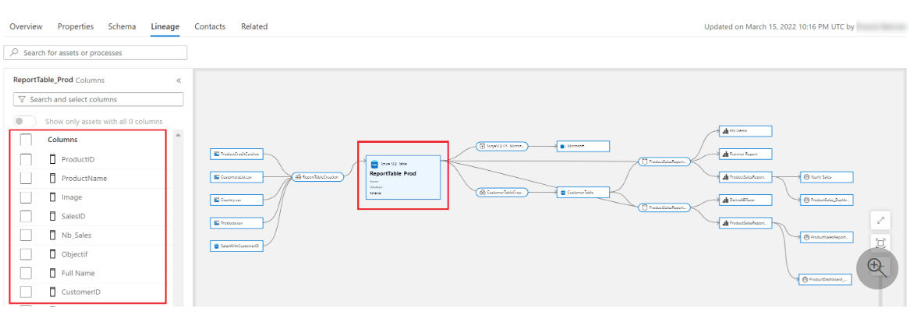

**Note**

The lineage view is a powerful way to understand the transformation process an asset has undergone. Learn more about the [**lineage experience in Microsoft Purview data catalog**](https://learn.microsoft.com/en-us/azure/purview/concept-data-lineage#lineage-experience-in-azure-purview-data-catalog)

### Asset contacts and related assets

Asset contacts provide you contact details of experts or dataset owners with any questions. As a new analyst searching for the right data sources for your report, you may find these individuals helpful.

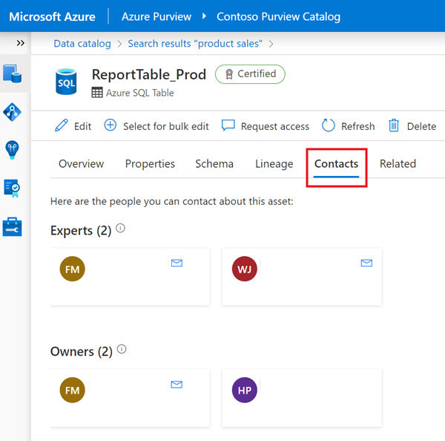

If needed, you can also navigate through the technical hierarchy of assets that are related to the current asset you're viewing.

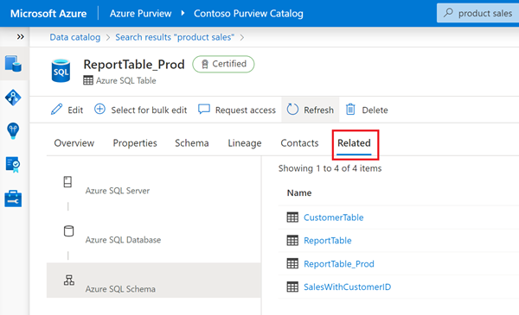

The ability to search the Microsoft Purview data catalog has the potential to break down data silos and enable the next level of enterprise analytics.

# Browse assets

Searching a data catalog is a great tool for data discovery you know what you're looking for. Often, you may not know how your data estate is structured. The Microsoft Purview data catalog offers a browse experience that enables exploration of available data, either by collection or by exploring the hierarchy of each data source in the catalog.

## Browse by collection or source type

If you're new to an organization or department, you may want to familiarize yourself with the contents of the data estate. From the Microsoft Purview Studio home page, select the “Browse assets” tile to browse either by collection or by source type.

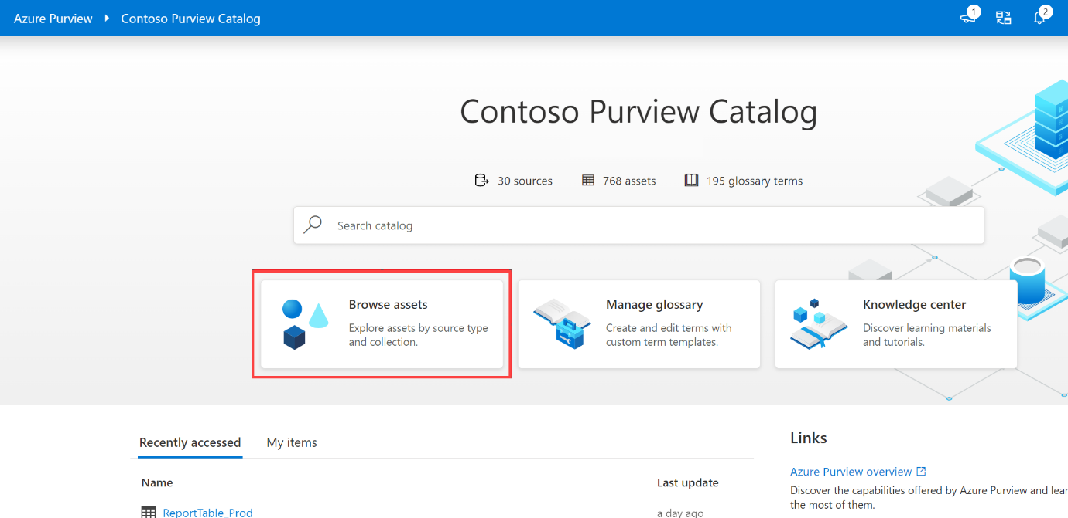

Here you can specify whether you'd like to browse by collection or by source type.

**Browse by collection** allows you to explore the different collections you're a data reader or curator for. You'll only see collections you have access to. Select a collection to get a list of assets in that collection with the facets and filters available in search.

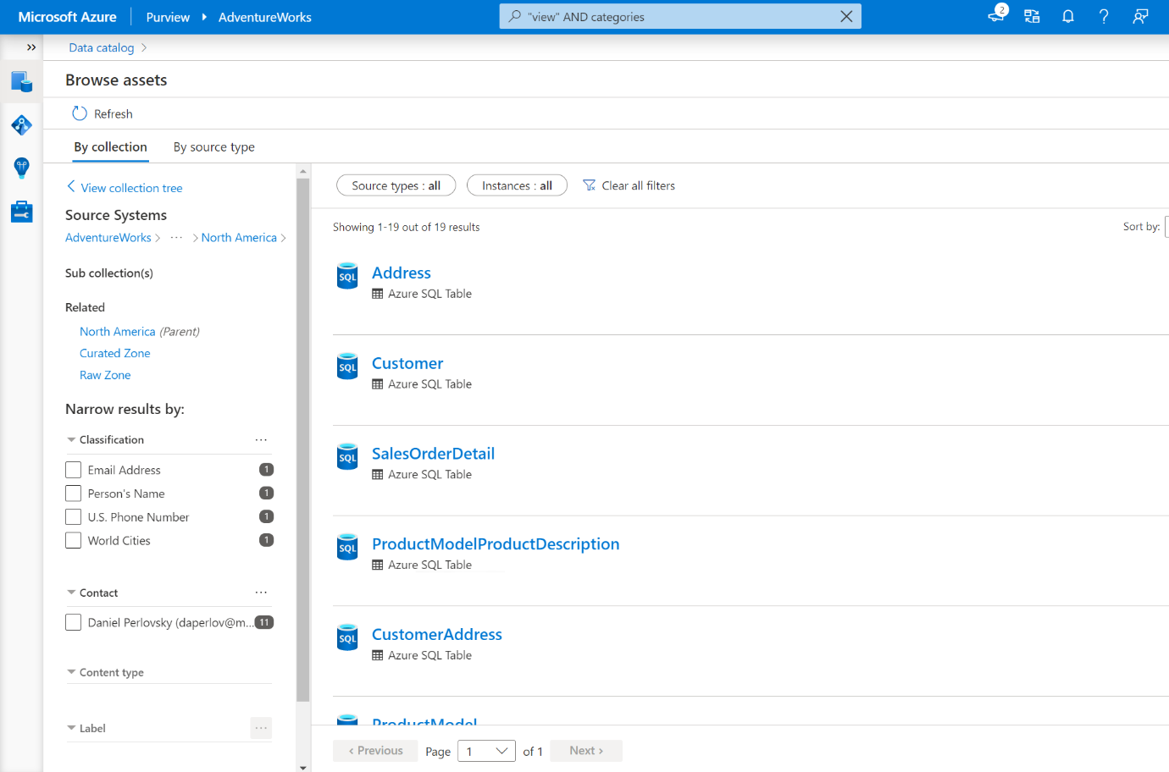

**Tip**

Collections are a tool to manage ownership and access control across assets and data sources. They also organize assets and sources into categories that are customized to match the business flow. See [**Create and manage collections in Microsoft Purview**](https://learn.microsoft.com/en-us/azure/purview/how-to-create-and-manage-collections) to learn more.

**Browse by source type** allows you to explore the hierarchies of data sources using an explorer view.

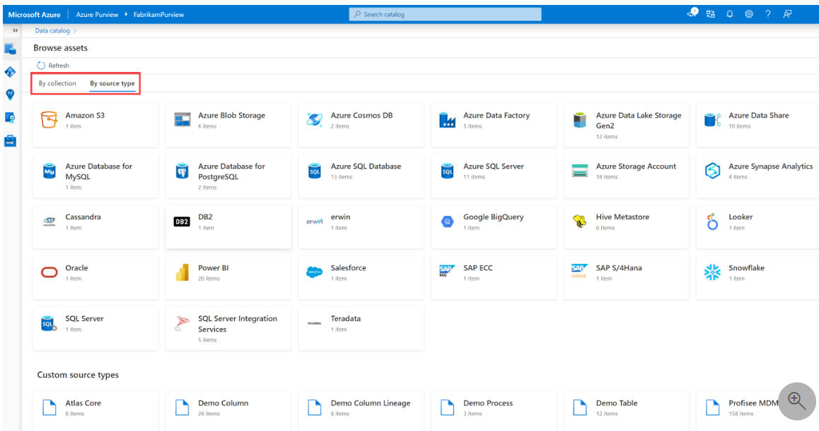

After selecting a tile associated with a data source type, you'll see a list of assets belonging to that type. From there, you'll be able to use the explorer view to see parent and child assets.

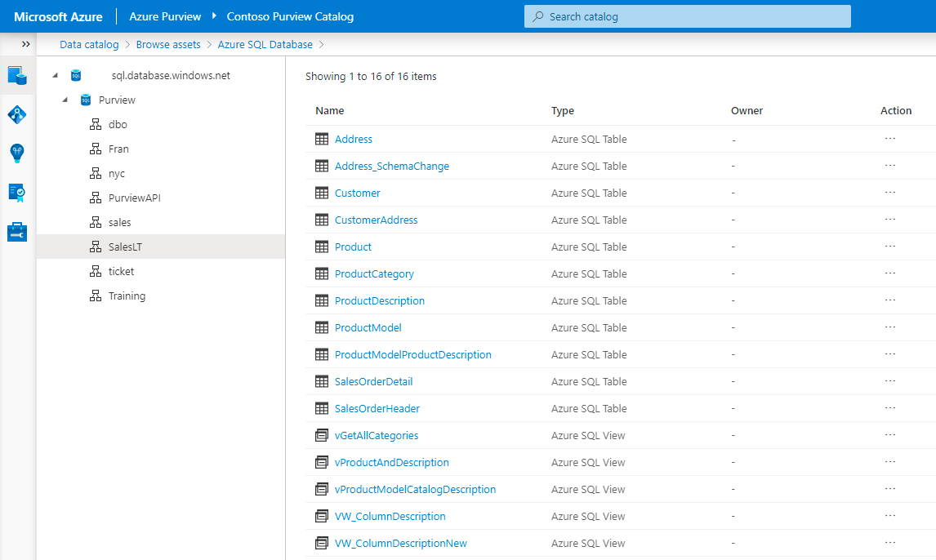

The Microsoft Purview data catalog browse experience enables analysts or data consumers to explore what data is available in many different ways. Microsoft Purview has the ability to enable users access to data you may not have known about before. The possibilities are endless so long as your organization's data stewards have scanned and classified data across the estate.

# Use assets with Power BI

The integration of Microsoft Purview and Power BI makes it possible to gain a more complete understanding of the data across your estate.

## Request access to assets

In your search or browsing session, you may come across assets that you don't have access to. Microsoft Purview makes it simple to request access directly from the Data Catalog by using the “Request access” button. Requesting access will kick off a workflow that manages requests and approvals.

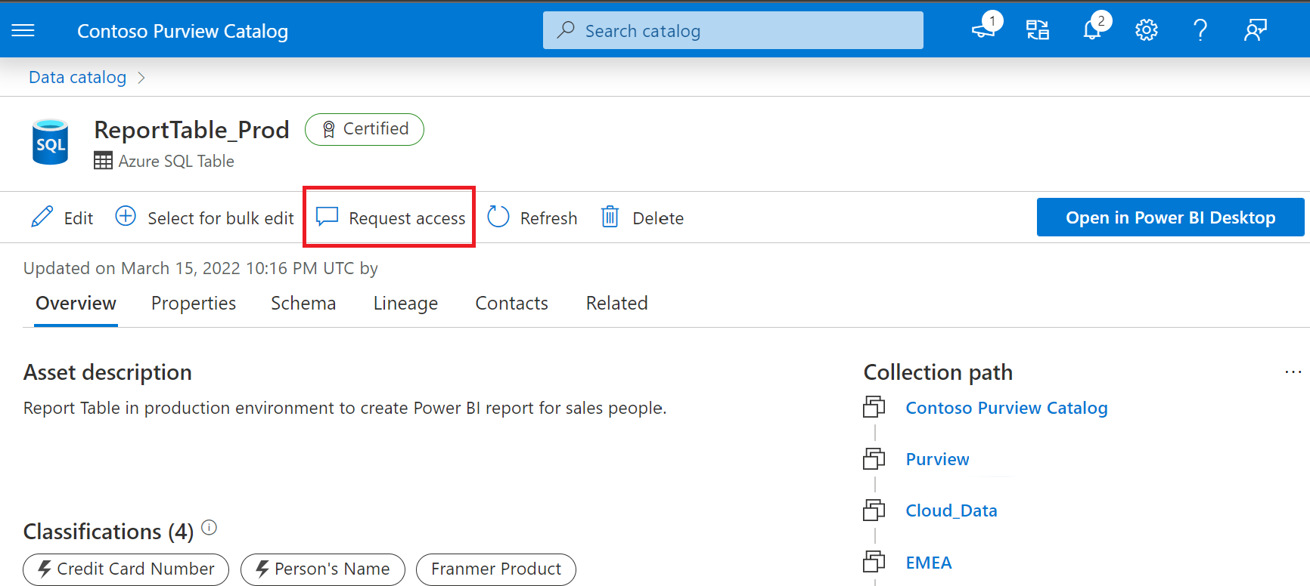

## Build a Power BI report using data discovered in Purview

Working as a new analyst, you've taken the time to search and browse assets and now you'd like to use those trusted assets in a Power BI report. Purview makes it simple, with the ability to open the asset in Power BI desktop.

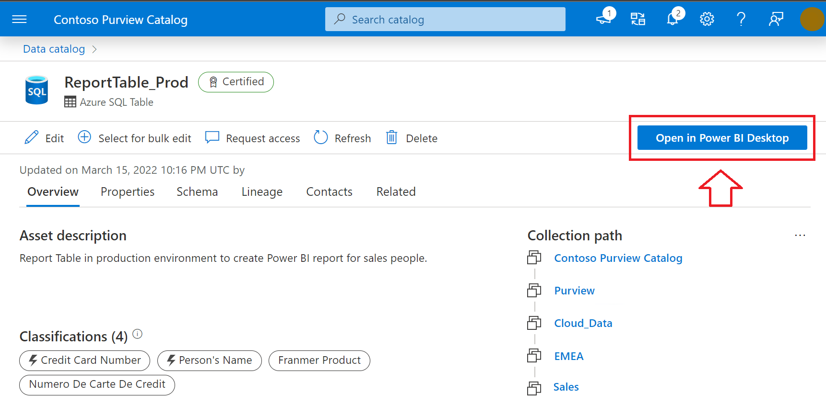

Selecting Open in Power BI Desktop initiates the download of a Power BI Data Source file (PBIDS) you can open with Power BI Desktop. PBIDS files contain a connection to the data source, so all you need to do is enter credentials upon opening the file and you're ready to start building.

## Scan a Power BI tenant

In addition to using Purview to find trusted data sources in the data estate to build reports, you can also scan your Power BI tenant to manage and catalog assets. The metadata of Power BI assets, and information about their lineage across Power BI workspaces and their connections to data sources, are then available in Microsoft Purview.

**Note**

See [**Connect to and manage a Power BI tenant in Microsoft Purview**](https://learn.microsoft.com/en-us/azure/purview/register-scan-power-bi-tenant) for more details.

# Integrate with Azure Synapse Analytics

Microsoft Purview can be integrated directly into Azure Synapse. If Azure Synapse Studio is massively deployed in your organization, you can get the data catalog experience directly in Azure Synapse Studio.

This integrated experience allows you to discover Microsoft Purview assets, interact with them through Synapse capabilities, and push lineage information to Microsoft Purview.

**Note**

To connect an Microsoft Purview Account to a Synapse workspace, you need 2 types of permissions. You need a contributor role in Synapse workspace from Azure portal identity and access management (IAM). You also need access to that Microsoft Purview Account. For more information, see [**Microsoft Purview permissions**](https://learn.microsoft.com/en-us/azure/purview/catalog-permissions).

Let’s imagine you need to find and understand some assets before working with them in pipelines or notebooks. From Azure Synapse Studio, you can easily query your Microsoft Purview data catalog.

In Azure Synapse Studio, from the **Data** blade on the left, select **Purview** in the dropdown next to the search bar.

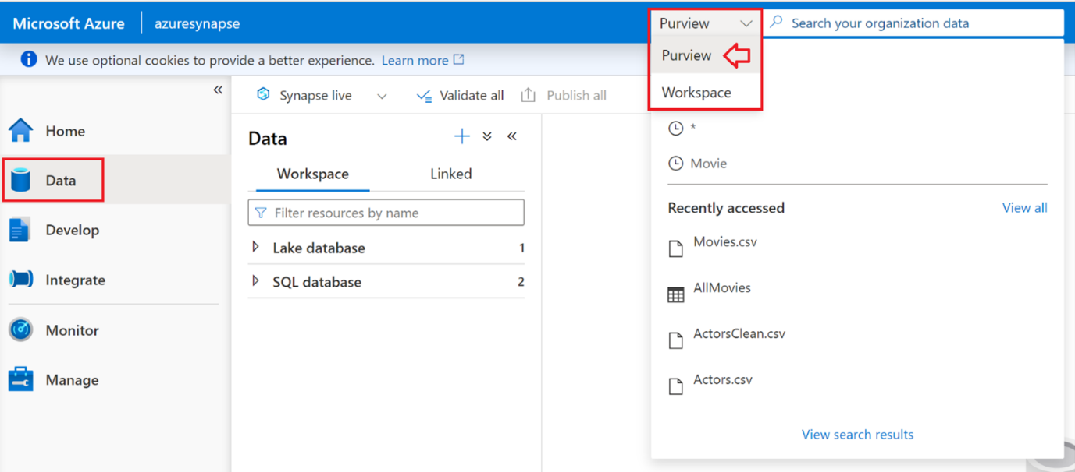

Search for the asset that exists in Purview. Imagine you're looking for movie files. Enter the keyword **movie** in the search bar, and fine tune your search by selecting **Files** as the object type and **Raw** as the collection.

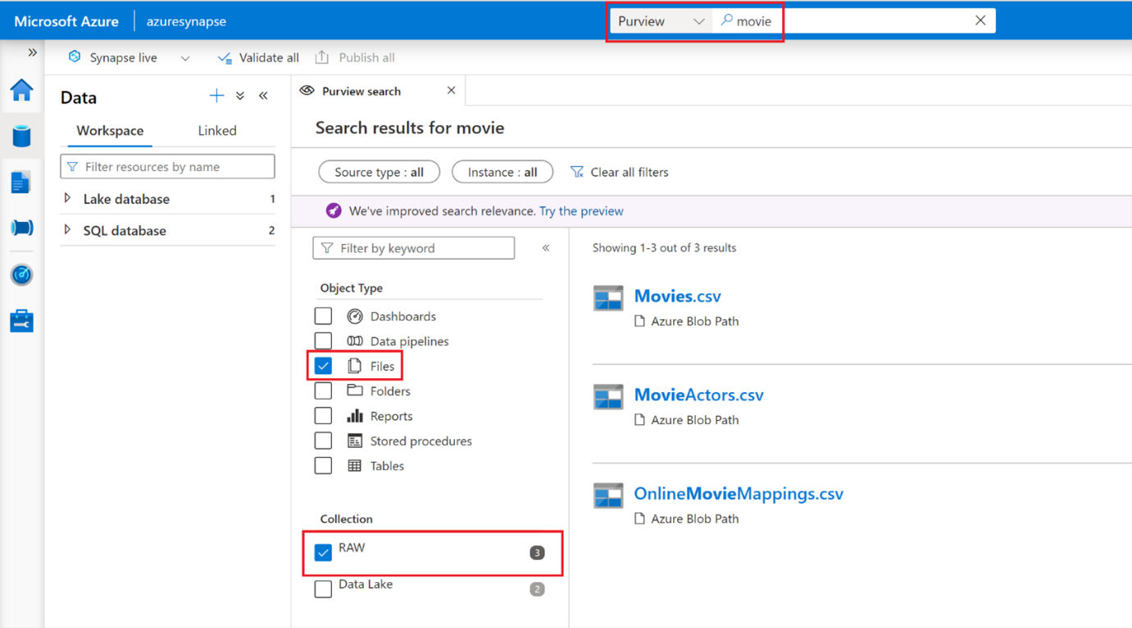

Select the first asset “Movies.csv” to get asset details. Because you are in Azure Synapse Studio, you can also leverage Azure Synapse capabilities.

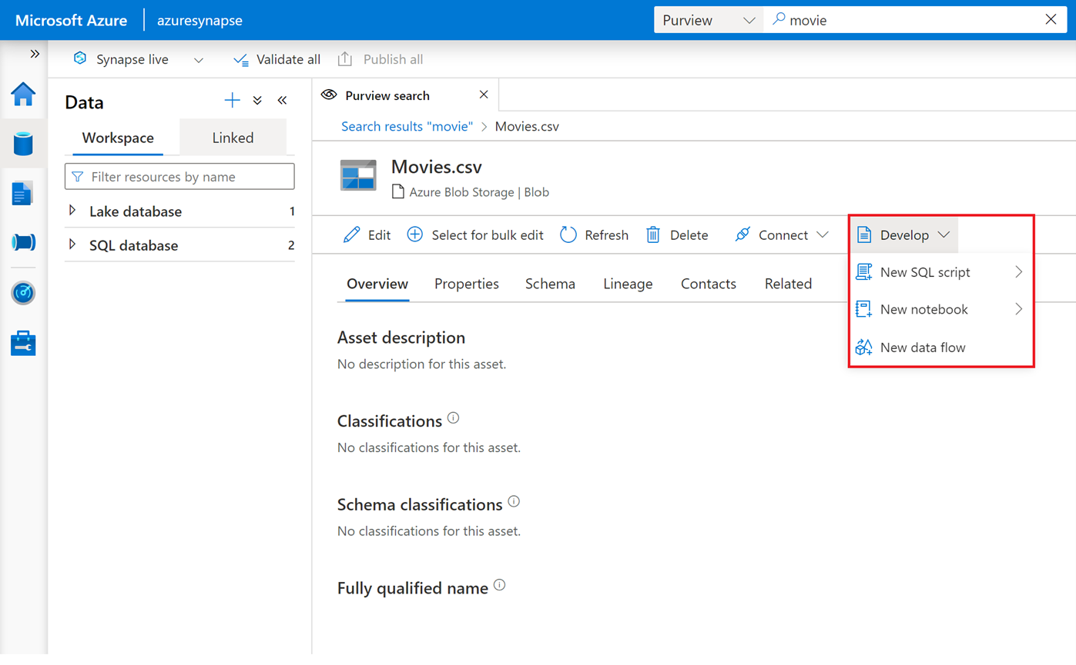

For instance, you can use Azure Synapse serverless to query your assets. Select **Develop**, **New SQL Script** and **Select top 100**.

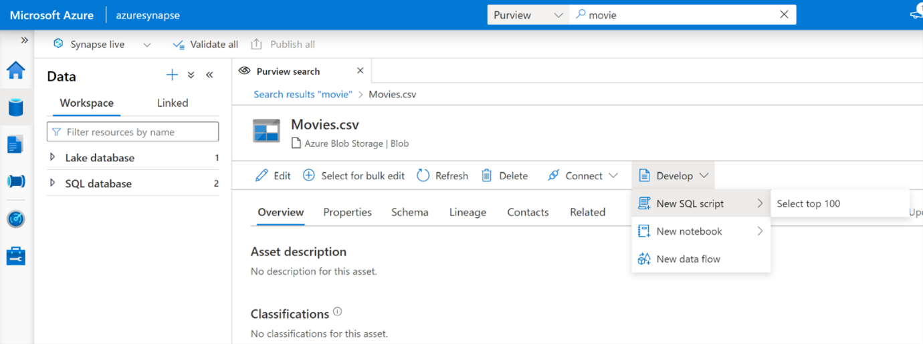

Double check you're connected to your serveless instance and select **Run** to execute the script and get an overview of your data.

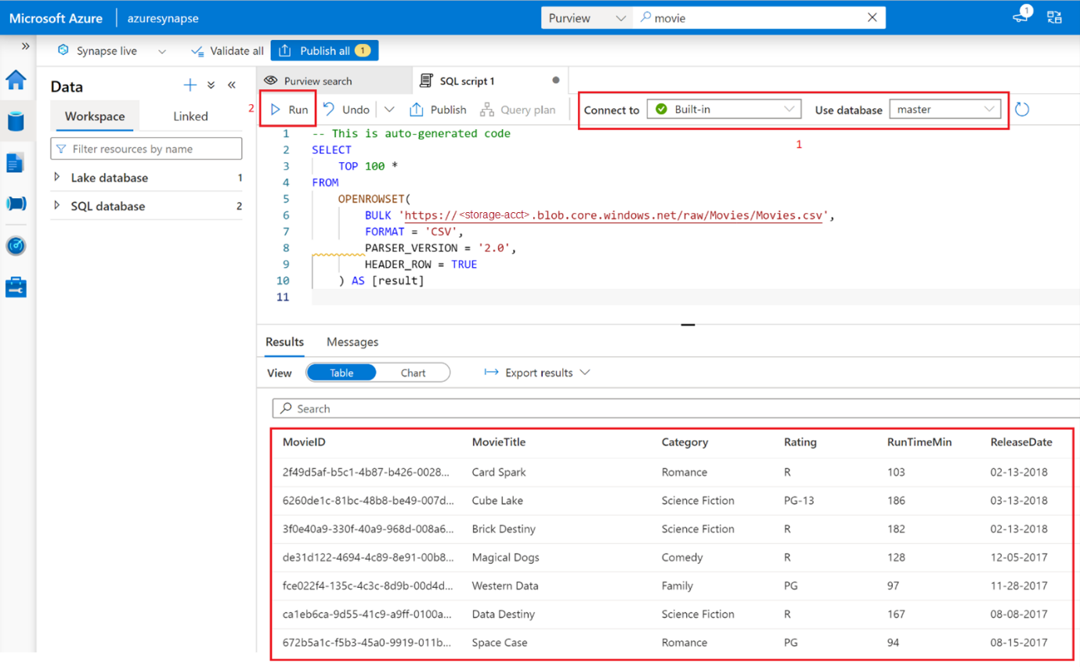

After reviewing data, you can use the asset, for example, adding to a new dataflow in Azure Synapse.

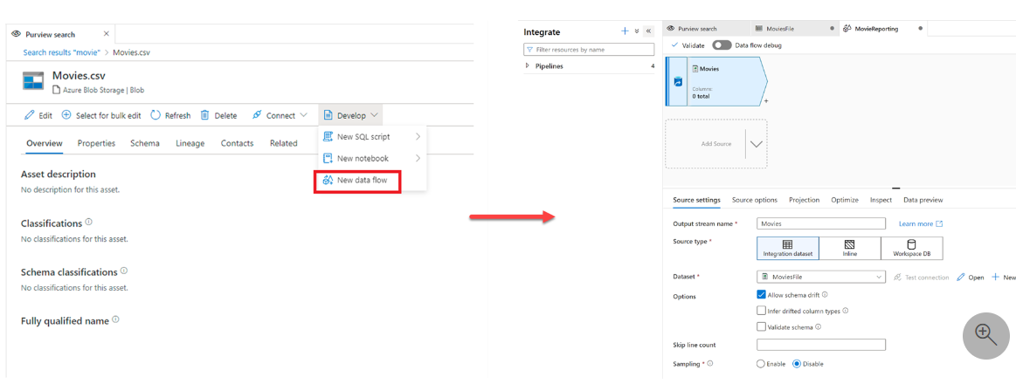

**Note**

See [**Connect an Microsoft Purview Account**](https://learn.microsoft.com/en-us/azure/synapse-analytics/catalog-and-governance/quickstart-connect-azure-purview) for detailed information about integrating Microsoft Purview into Azure Synapse Analytics.

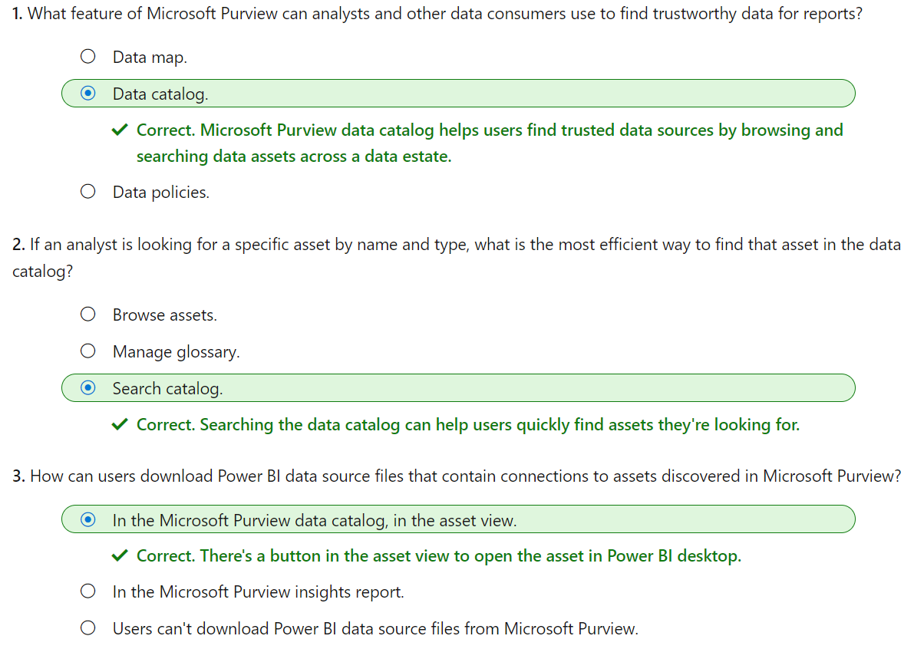

# Catalog data artifacts by using Microsoft Purview

The Microsoft Purview Data Catalog offers a browse experience that enables users to explore available data. Users can explore the data catalog either by collection or through traversing the hierarchy of each data source. The first step in understanding the contents of your data map is registering and scanning data, after which you can classify data for easy identification of assets to use for reporting.

# Register and scan data

Registration and scanning of data enables discoverability of data across an estate.

Before you can register and scan data, it’s important to understand the concept of collections. In Microsoft Purview Data Catalog, collections are key concept because they drive permissions and asset protection. Collections are also used to understand data estate health and catalog usage and adoption, as featured in the data stewardship section of your [Data Estate Insights](https://learn.microsoft.com/en-us/azure/purview/data-stewardship).

## Collections

The data map is at the core of Microsoft Purview, which keeps an up-to-date map of assets and their metadata across your data estate. To hydrate the data map, you need to register and scan your data sources, which is done at the collection level. Collections support organizational mapping of metadata. By using collections, you can manage and maintain data sources, scans, and assets in a hierarchy instead of a flat structure. Collections allow you to build a custom hierarchical model of your data landscape based on how your organization plans to use Microsoft Purview to govern your landscape.

Collections also provide a security boundary for your metadata in the data map. Access to collections, data sources, and metadata is set up and maintained based on the collection’s hierarchy in Microsoft Purview, following a least-privilege model:

* Users have the minimum amount of access they need to do their jobs.
* Users don't have access to sensitive data that they don't need.

Data sources are registered at the collection level. Scan results can then be sent to this collection or a sub collection. The image below displays the structure of a collection.

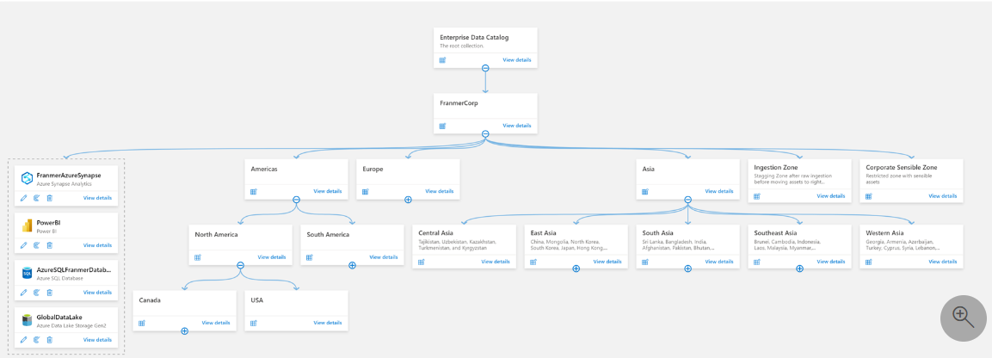

**Tip**

Learn more about [**Microsoft Purview collections architectures and best practices.**](https://learn.microsoft.com/en-us/azure/purview/concept-best-practices-collections)

## Register and scan data sources

Data governance use begins at collection level, with the registration of data sources in Microsoft Purview governance portal. Microsoft Purview supports an array of data sources. Data teams (analysts, engineers, and scientists) may not be actively registering and scanning data in Microsoft Purview, but it's critical that data consumers understand governance efforts. Registering and scanning assets requires **Data Curator** permissions.

**Important**

Data registered and scanned in Microsoft Purview only collects metadata information. Data remains in its location and isn't migrated to any other platform.

### Register a data source

Registering a data source is done from within the Azure portal. Once you have a Microsoft Purview service configured in Azure, you use the Microsoft Purview governance portal to register your data sources.

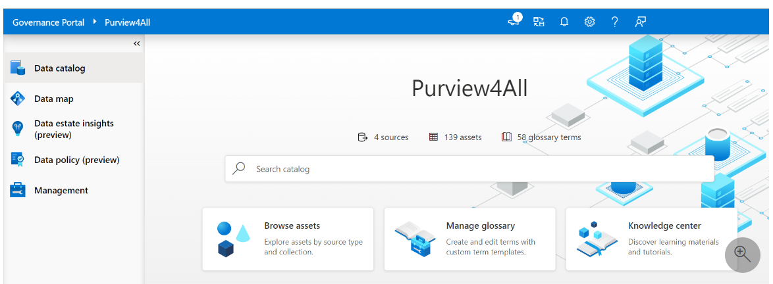

To register a data source, you'll select the icon to register a data source as displayed in the image below. Selecting this icon will give you access to all data source connectors.

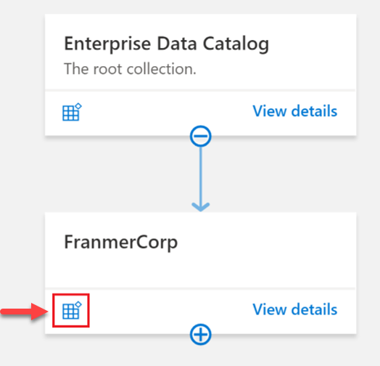

Below is a small sample of available connectors in Microsoft Purview Data Catalog. See [supported data sources and file types](https://learn.microsoft.com/en-us/azure/purview/azure-purview-connector-overview) for an up-to-date list of supported data sources and connectors.

[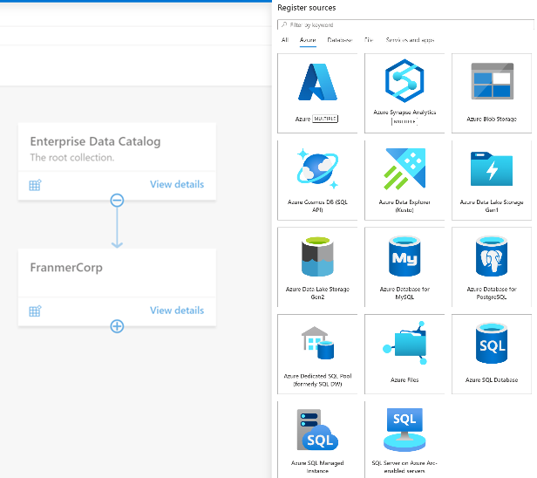](https://learn.microsoft.com/en-us/training/wwl-data-ai/catalog-data-artifacts-use-microsoft-purview/media/purview-connectors.png)

Registering a data source is straightforward, you need to complete the required fields. Authentication will be done during the scanning phase.

Each type of data source you choose will require specific information to complete the registration. For example, if your data sources reside in your Azure subscription, you'll choose the necessary subscription and storage account name.

### Scan a data source

Once you have data sources registered in the Microsoft Purview governance portal and displayed in the data map, you can set up scanning. The scanning process can be triggered to run immediately or can be scheduled to run on a periodic basis to keep your Microsoft Purview account up to date.

Scanning assets is as simple as selecting **New scan** from the resource as displayed in the data map.

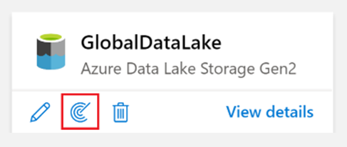

You'll now need to configure your scan and assign the following details:

* Assign a friendly name.
* Define which [integration runtime](https://learn.microsoft.com/en-us/azure/purview/manage-integration-runtimes) to use to perform the scan.
* [Create credentials](https://learn.microsoft.com/en-us/azure/purview/manage-credentials) to authenticate to your registered data sources.
* Choose a collection to send scan results.

After the basic configuration, you'll scope your scan, which allows you to choose just a specific zone of your data source. For instance, if you have a collection called “Raw” in your data map, you can define the scope to scan only the raw container of your data lake.

After configuring and scoping your scan, you'll define the scan rule set. A scan rule set is a container for grouping a set of scan rules together so that you can easily associate them with a scan. For example, you might create a default scan rule set for each of your data source types, and then use these scan rule sets by default for all scans within your company. You might also want users with the right permissions to create other scan rule sets with different configurations based on business need.

Once a scan is complete, you can refer to the scan details to view information about the number of scans completed, assets detected, assets classified, Scan information. It’s a good place to monitor scan progress, including success or failure.

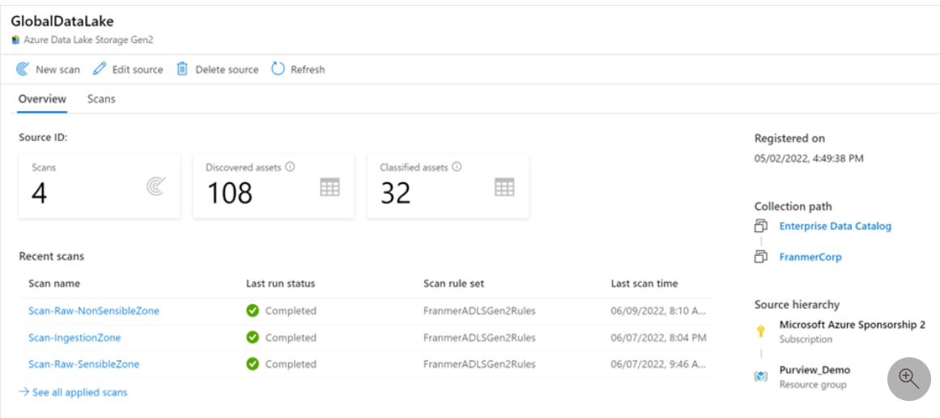

**Tip**

Refer to [**Scanning best practices**](https://learn.microsoft.com/en-us/azure/purview/concept-best-practices-scanning) for more information on scanning assets.

## Roles and permissions

Permissions in Microsoft Purview are assigned at **collection** level. Collections are used to organize assets and sources and can be thought of as a logical grouping of data assets.

Data teams looking to discover and use data need to be assigned the **Data Reader** role in a collection in Microsoft Purview. The Data Reader role enables users to find assets, but doesn't enable users to edit anything. The **Data Curator** role is required to edit information about assets, assign classifications, and associate assets with glossary entries. To set up scans via the Microsoft Purview Governance Portal, individuals need to be either a data curator on the collection or data curator and data source administrator where the source is registered.

When a Microsoft Purview account is created, it starts with a root collection that has the same name as the Microsoft Purview account itself. The creator of the Microsoft Purview account is automatically added as a Collection Admin, Data Source Admin, Data Curator, and Data Reader on this root collection, and can edit and manage this collection.

**Tip**

Learn more about [**Microsoft Purview permissions and access**](https://learn.microsoft.com/en-us/azure/purview/catalog-permissions#who-should-be-assigned-to-what-role).

# Classify and label data

Glossary terms, classifications and labels are all annotations to a data asset. Each of them have a different meaning in the context of the data catalog.

## What is data classification?

Classifications are annotations that can be assigned to entities. The flexibility of classifications enables you to use them for multiple scenarios such as:

* understanding the nature of data stored in the data assets
* defining access control policies

Classification is based on the business context of the data. For example, you might classify assets by Passport Number, Driver's License Number, Credit Card Number, SWIFT Code, Person’s Name, and so on. Microsoft Purview has more than 200 system classifiers today. Users can also define their own classifiers in the data catalog. As part of the scanning process, classifications are automatically detected and applied as metadata within the Purview Data Catalog.

### Classification rules

In Microsoft Purview, you can apply system or custom classifications on a file, table, or column asset. Microsoft Purview makes use of Regex patterns and bloom filters to classify data. These classifications are then associated with the metadata discovered in the Azure Purview Data Catalog.

Metadata is used to help describe the data that is being scanned and made available in the catalog. During the configuration of a scan set, you can specify classification rules to apply during the scan that will also serve as metadata. The existing classification rules fall under five major categories:

* Government - covers attributes such as government identity cards, driver license numbers, passport numbers, etc.
* Financial - covers attributes such as bank account numbers or credit card numbers.
* Personal - personal information such as a person's age, date of birth, email address, phone number, etc.
* Security - attributes like passwords that may be stored.
* Miscellaneous - attributes not covered in the other categories.

## Why classify data?

A good data governance strategy includes a process to classify data to understand its level of confidentiality, determine if the data source is compliant with various regulations, or how long to retain it for. Classification in Microsoft Purview makes data assets easier to understand, search, and govern. Classification can also help you implement measures to protect sensitive data.

Once a classification is tagged to a data source after a scan, you can generate reports and insights to gain a stronger understanding of your data estate. Because classification is based on the business context of the data, it can help bridge the gap between the business and the data team.

### Data classification: system vs. custom classification

Microsoft Purview supports both system and custom classifications. There are over +200 system classifications available in Microsoft Purview today. Data teams need to know that if necessary classifications aren't available out of the box, they can work with the data stewards to create custom classifications, to meet their own organizational data governance requirements.

**Important**

For the entire list of available system classifications, see [**Supported classifications in Microsoft Purview**](https://learn.microsoft.com/en-us/azure/purview/supported-classifications).

### Who creates custom classifications?

Purview Data Curators can create, update, and delete custom classifiers and classification rules. Purview Data Readers can only view classifiers and classification rules.

In practical terms, Data Curators may not be members of the data team. It is however critical that data team members understand classification to be able to successfully work together and govern data across an organization.

## What are data labels?

The Microsoft Purview Data Map supports labeling structured and unstructured data stored across various data sources. This may sound familiar to you from other Microsoft technologies - and may be known as sensitivity labels. The data map extends the use of sensitivity labels from Microsoft Purview Information Protection to assets stored in infrastructure cloud locations and structured data sources.

Labels are defined in Microsoft Purview Information Protection, and you can extend the application to Microsoft Purview Data Catalog.

The screenshot below shows both data classification and label in the Microsoft Purview Data Catalog. You can see that this Azure SQL table has a column called “CreditCard”:

* Classified as “Credit Card Number” because scan detected numbers corresponding to credit card pattern rules.
* Labeled as “Confidential – Finance” because credit card number was defined in your organization as confidential information (and this label brings encryption).

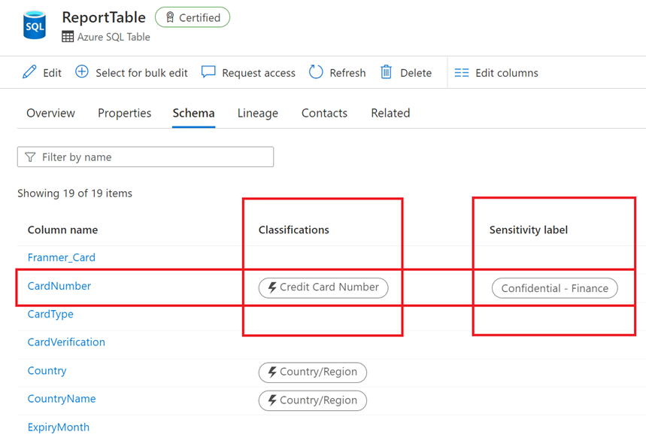

# Search the data catalog

A data catalog search can empower business and data analysts to find and interpret data. The data catalog provides intelligent recommendations based on data relationships, business context, and search history. The Purview data catalog can assist data teams by adding business context to assets to drive analytics, AI and ML initiatives.

The data catalog can be searched by keyword, object type, collection, classification, contact, label, or assigned term. Results can then be sorted by relevance or name.

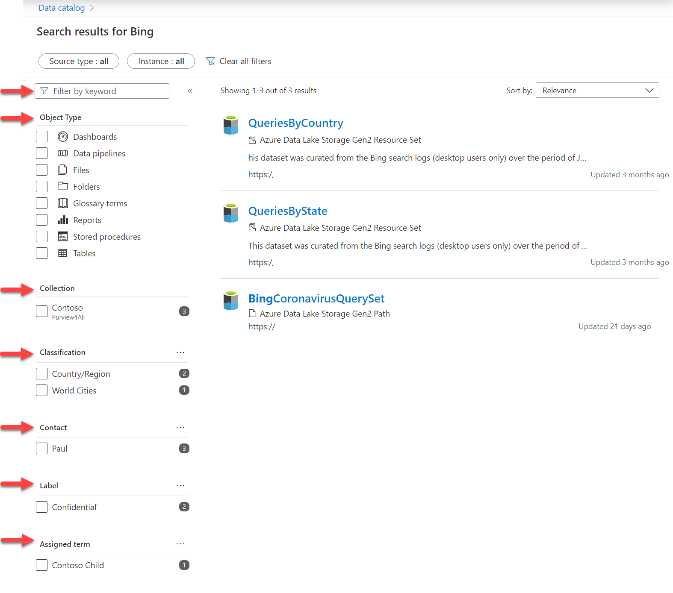

For more information about searching for trusted assets for reporting, see [Discover trusted data using Microsoft Purview](https://learn.microsoft.com/en-us/learn/modules/discover-trusted-data-use-azure-purview/).

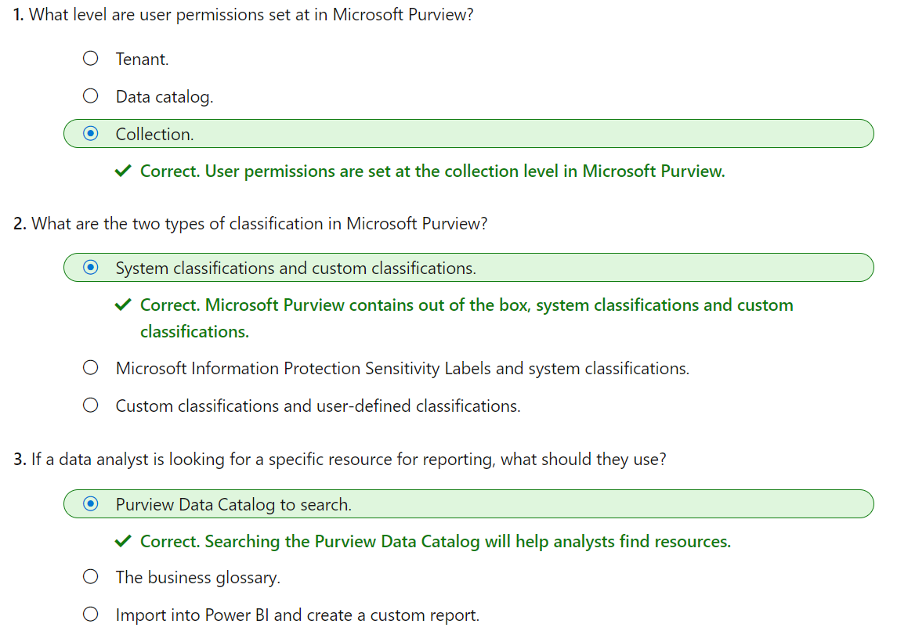

# Manage Power BI assets by using Microsoft Purview

Improve data governance and asset discovery using Power BI and Microsoft Purview integration.

## Learning objectives

By the end of this module, you’ll be able to:

* Register and scan a Power BI tenant.
* Use the search and browse functions to find data assets.
* Describe the schema details and data lineage tracing of Power BI data assets.

As the landscape of enterprise data continues to grow, it's critical to get an accurate view of your organization's data. Microsoft Purview and Power BI integration enables you to scan your entire Power BI tenant to search and browse Power BI assets, explore enhanced dataset metadata, trace end-to-end data lineage, and drill-down into datasets in Power BI for further analysis.

# Register and scan a Power BI tenant

To get an understanding of what is going on in your Power BI tenant, you can perform a full scan in Microsoft Purview to view the schema and lineage of assets across all workspaces. After, you can schedule incremental scans on workspaces that have changed since the previous scan.

There are a few pre-requisite steps required to scan your Power BI tenant in Microsoft Purview.

**Tip**

If you need to create a Microsoft Purview account, see the **[quickstart guide](https://learn.microsoft.com/en-us/azure/purview/create-catalog-portal)** to create a Microsoft Purview account in the Azure Portal.

## Establish a connection between Microsoft Purview and Power BI

Microsoft Purview can connect to and scan Power BI either in the same tenant or across tenants. You'll need to set up authentication either by using a Managed Identity or a Delegated Authentication.

**Note**

See [**Register and scan a Power BI tenant**](https://learn.microsoft.com/en-us/azure/purview/register-scan-power-bi-tenant) to learn more about the set-up and authentication of Power BI connections in same and cross-tenant scenarios.

### Authenticate to Power BI tenant

Give Microsoft Purview permissions to access your Power BI tenant.

If you're using **Managed Identity** to authenticate to Power BI, you'll need to create a security group in Azure Active Directory, and add your Microsoft Purview managed identity to this security group.

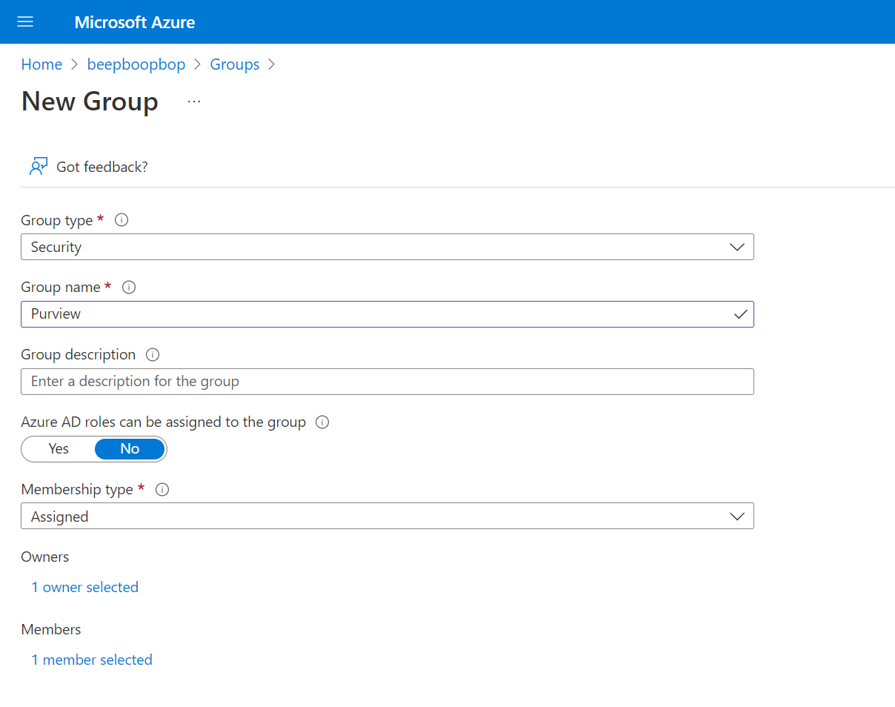

If a security group containing the Purview managed identity already exists, you can proceed to configuring the Power BI tenant.

### Configure Power BI tenant

Next you need to enable access to Power BI by Microsoft Purview in Power BI itself. This is done by enabling Allow service principals to use read-only Power BI admin APIs in the Power BI admin portal.

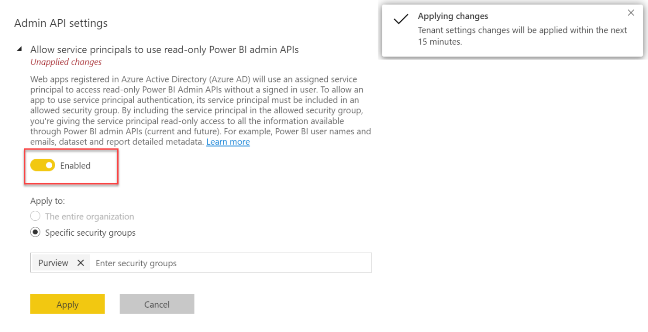

## Register and scan Power BI

Now that you've got access set up in both Microsoft Purview and Power BI, you can register and scan your Power BI tenant.

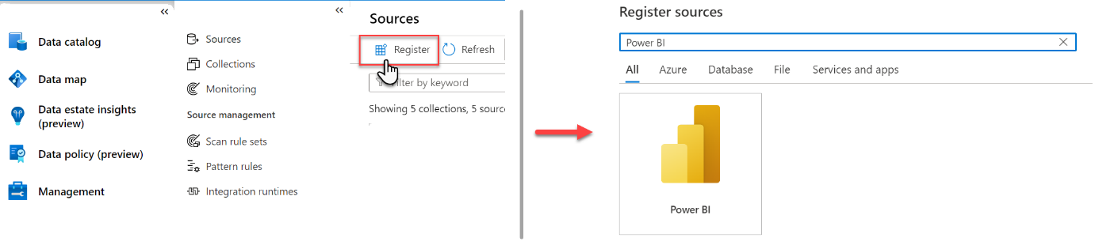

After registering the Power BI tenant, initiate the scan by selecting **New scan**. Give your scan a name and step through the interface, where you'll be able to to exclude personal workspaces, confirm integration runtime and credentials, and select a connection. Test the connection to ensure authentication is set up properly.

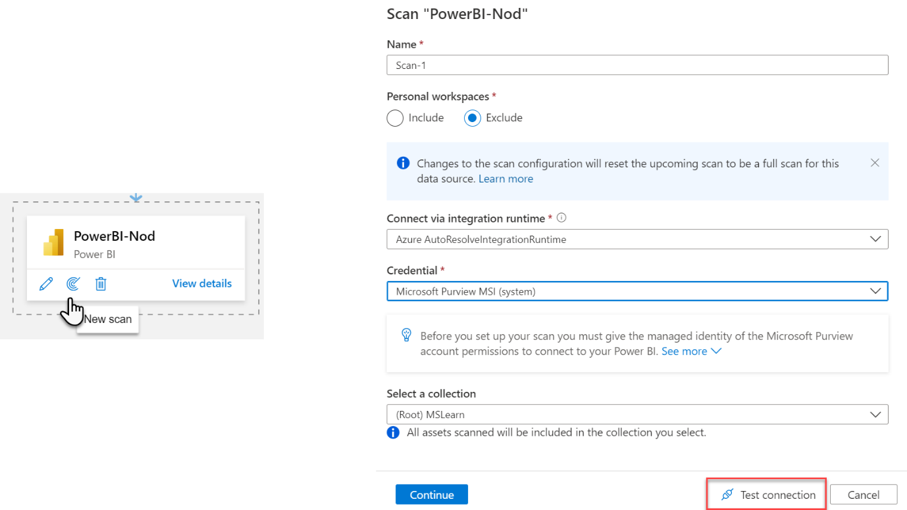

**Note**

If you're performing the scan, you must be both a Data Source Administrator and a Data Reader. See [**Access control in the Microsoft Purview Data Map**](https://learn.microsoft.com/en-us/azure/purview/catalog-permissions) for details on permissions.

You're able to track the progress of the scan in the data map, and once the scan is complete, you'll be able to search and browse the contents of your entire Power BI tenant!

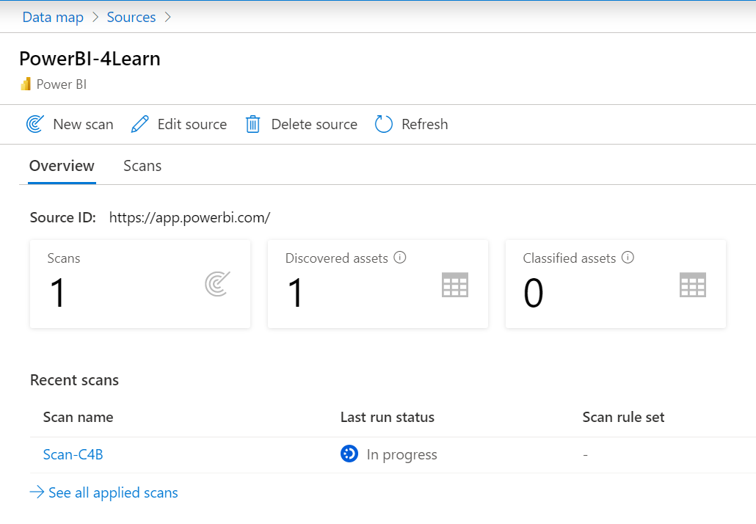

If you're having any issues with scanning your Power BI tenant, see [Troubleshoot Power BI tenant scans in Microsoft Purview](https://learn.microsoft.com/en-us/azure/purview/register-scan-power-bi-tenant-troubleshoot) for details and helpful hints.

# Search and browse Power BI assets

After data is registered and scanned, analysts and data consumers need to be able to find data, view enhanced metadata, and track data lineage. Search and browse in the Purview Data Catalog enables you to quickly find trustworthy data.

After scanning your Power BI tenant, you'll see those assets appear in the search results, including underlying data sources.

## Search the Microsoft Purview Data Catalog

From the Microsoft Purview Governance Portal, you can type relevant keywords to start discovering assets. In this scenario, you're looking for "sales."

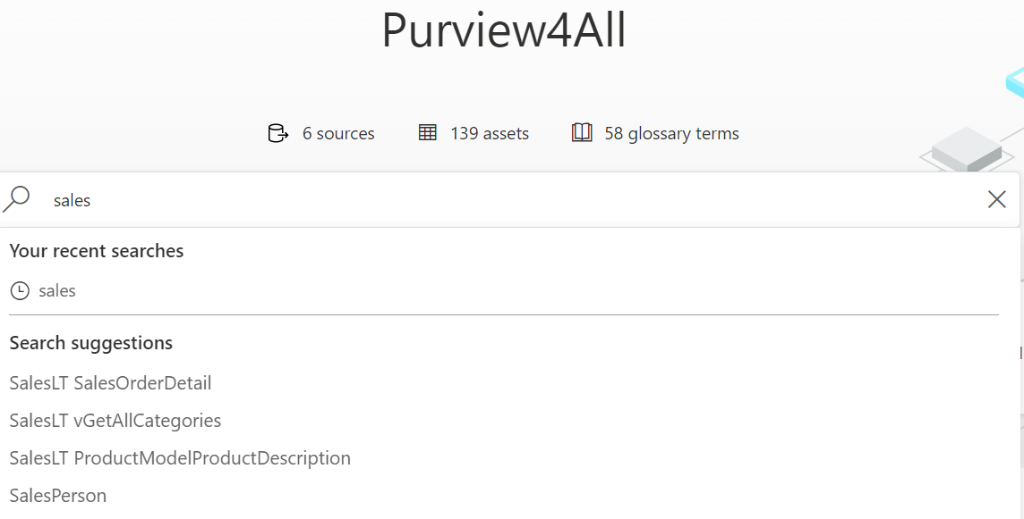

The screenshot below displays the search result, with all assets corresponding to the keywords entered in the search engine. Notice the appearance of Power BI assets.

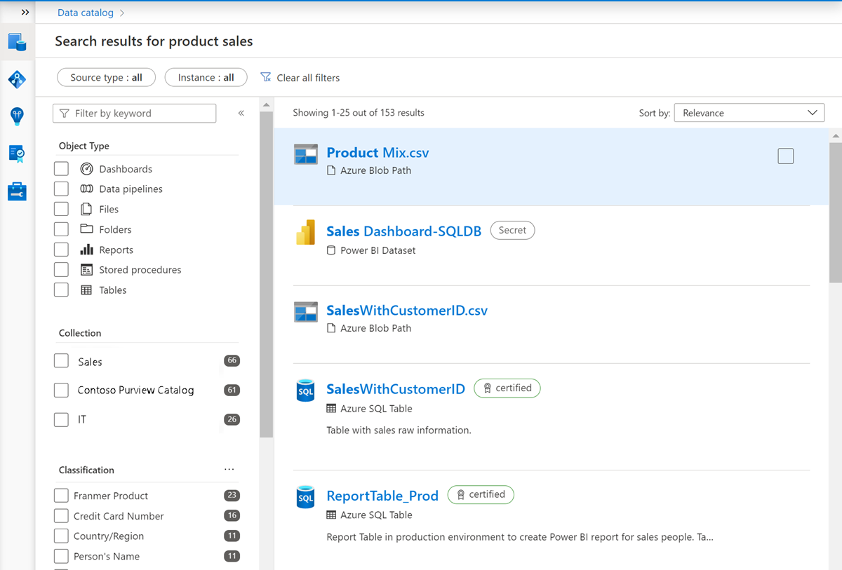

You can fine-tune your search using the filters on the left side of the page. Filters available include source type, keyword, object type, collection, classification, contact, label, and glossary term.

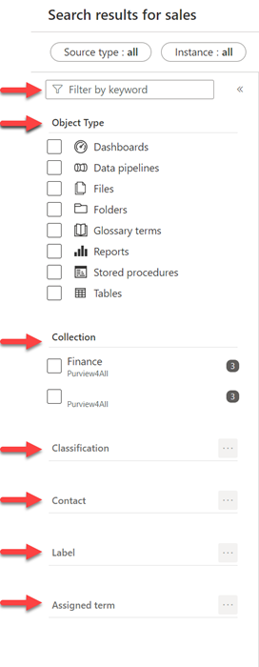

## Browse the Microsoft Purview Data Catalog

Searching for specific assets is great if you know what you're looking for, but analysts and data consumers may not know exactly how their data estate is structured. The browse experience enables you to explore what data is available, either by collection or through traversing the hierarchy of each data source in the catalog.

To access the browse experience, select **Browse assets** from the governance portal home page.

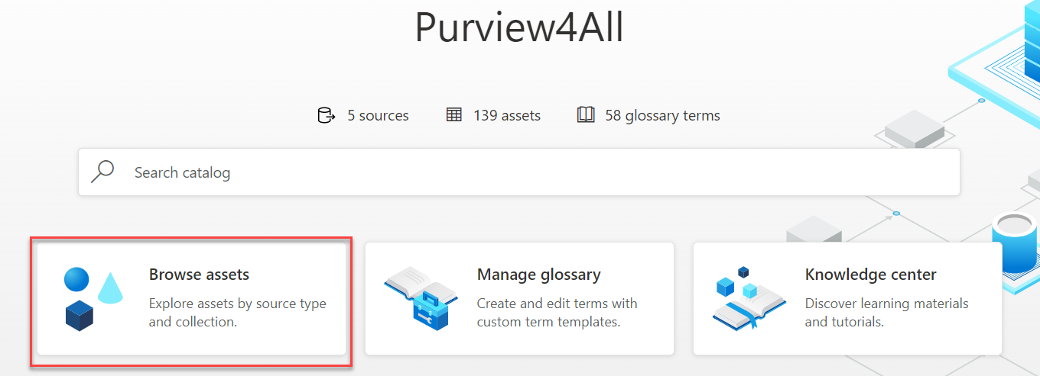

You can browse the data catalog either by collection or by source type, depending on your needs. Browsing by either collection or source type allows you to see assets you have access to. Once you find the asset you're looking for, you can select it to see details on schema, lineage, and a detailed classification list.

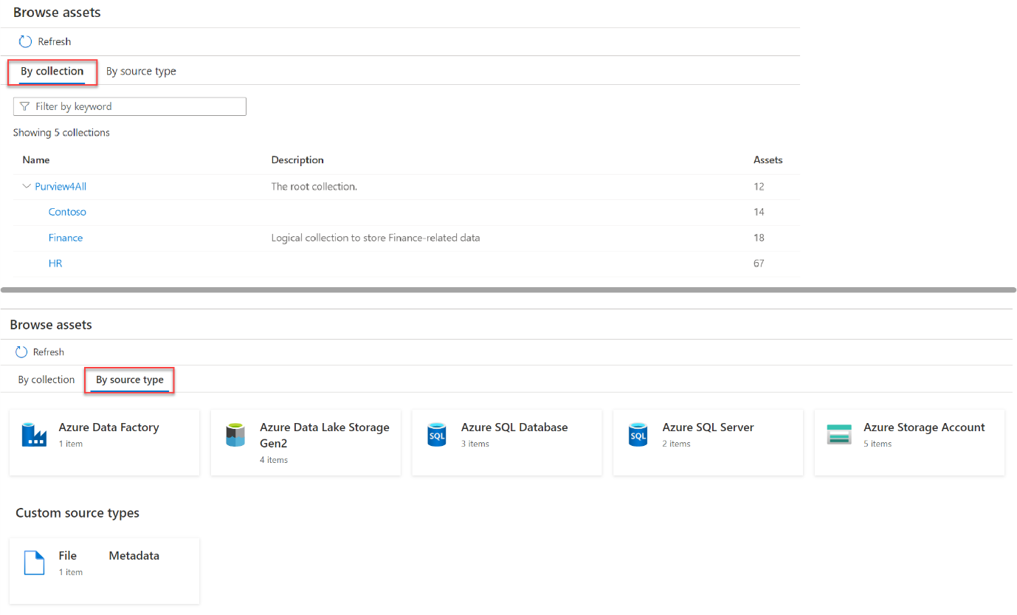

Uniquely, browsing by source type allows you to see the hierarchies of data sources using an explorer view. This is a helpful and familiar way to navigate to see lists of scanned assets.

**Note**

Assets in Purview are organized by collection and permissions are granted at collection level. Both searching and browsing require data reader permissions. See [**Access control in the Microsoft Purview Data Map**](https://learn.microsoft.com/en-us/azure/purview/catalog-permissions) for details on permissions.

Select an asset to see details about the properties, schema, lineage, contacts, and related assets.

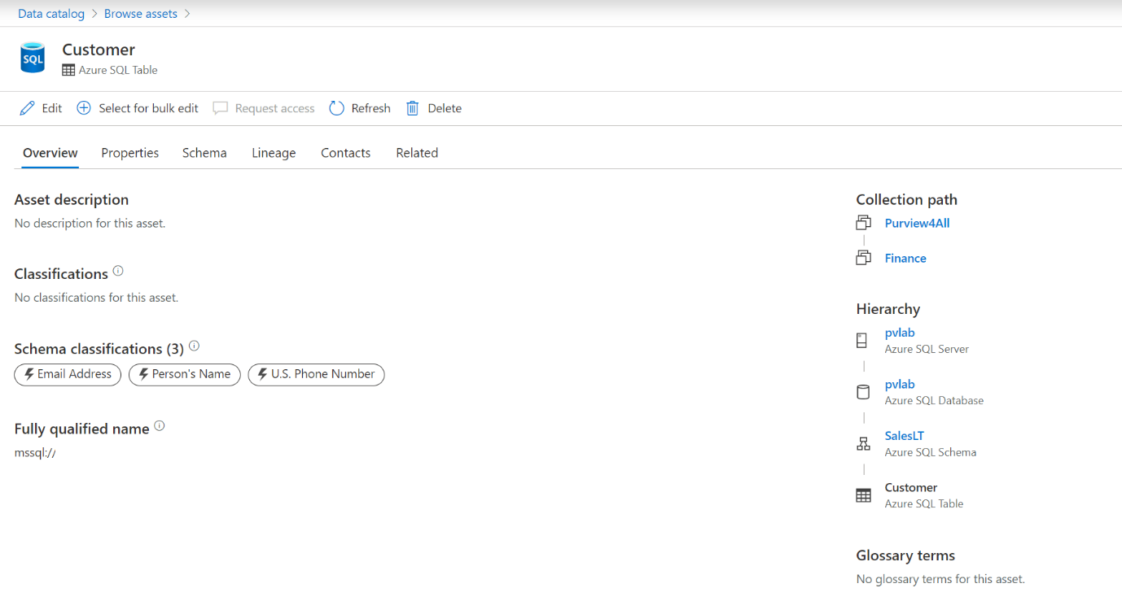

# View Power BI metadata and lineage

Purview and Power BI together are powerful, enhancing the ability of the search and browse features to see both the schema and lineage of Power BI assets.

## Extend your search with enhanced metadata

Metadata scanning facilitates governance by making it possible to catalog and report on the metadata of your organization's Power BI artifacts. The results of metadata scanning are displayed on the schema tab of the asset.

**Note**

Metadata scanning must be enabled in the Power BI admin portal. See [**Set up metadata scanning in your organization**](https://learn.microsoft.com/en-us/power-bi/admin/service-admin-metadata-scanning-setup) to learn more.

After performing a search in the Purview Governance Portal, select a Power BI asset from your search result to see the sensitivity labels and endorsement metadata. Additional business metadata includes the dataset user configuration, create datetime, and description.

Under the Schema tab, you can see the list of all the tables, columns, and measures created inside the Power BI dataset.

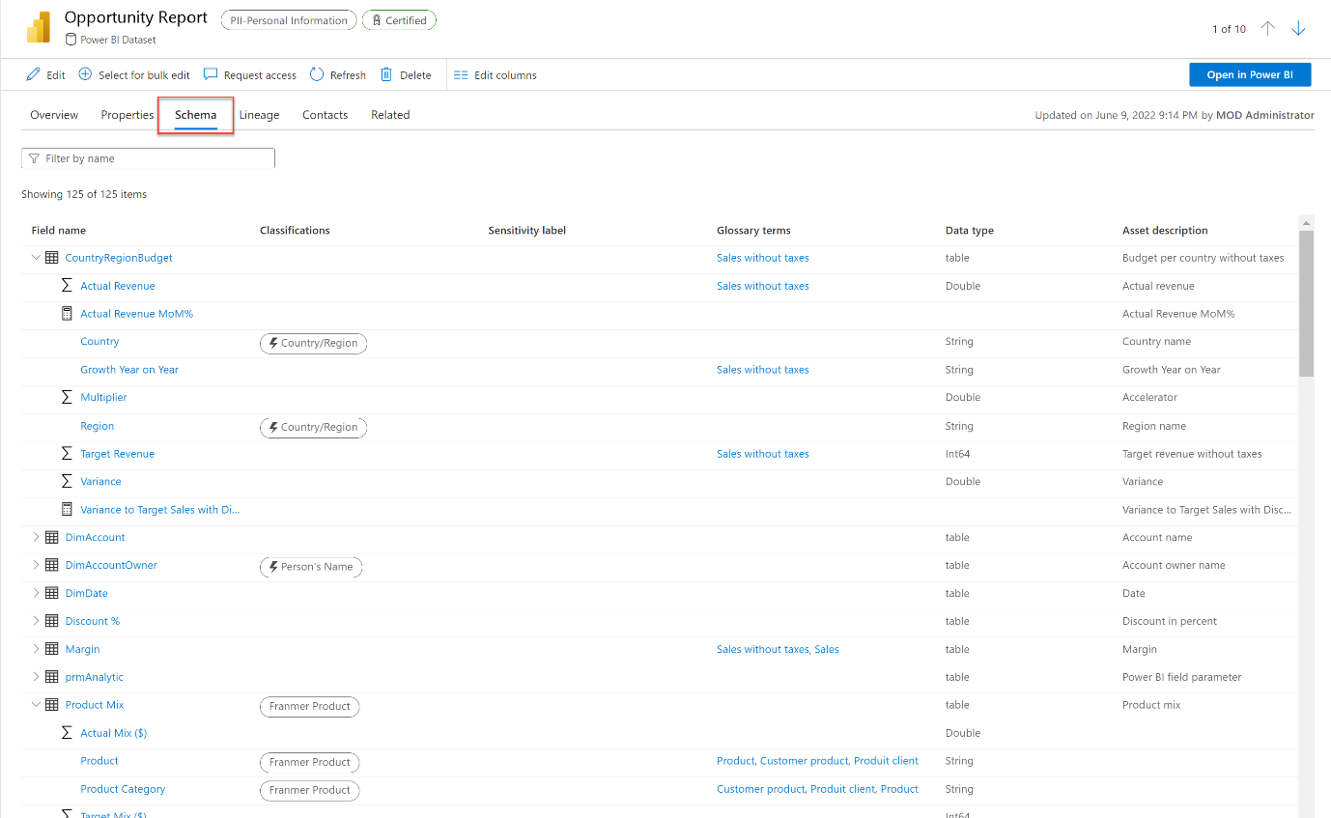

For more detail, selecting a particular field within the schema tab will take you to the details for that field. You can then view the overview, properties, lineage, contacts, and related assets for that particular field.

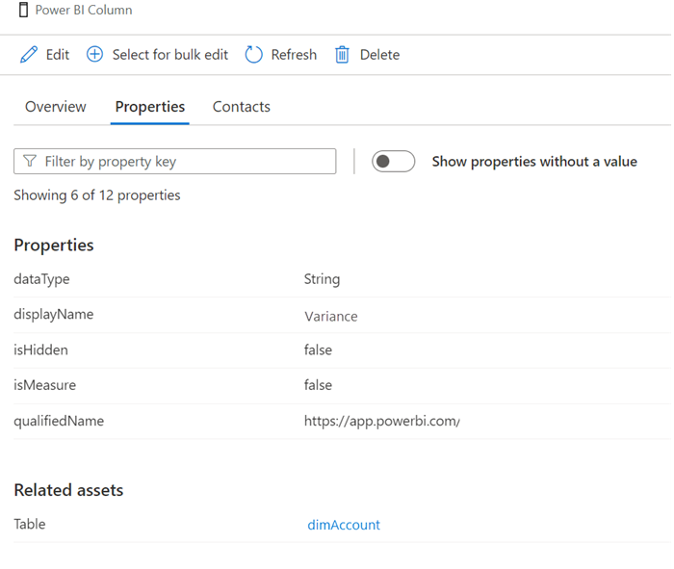

Metadata scanning requires no special license. It works for all of your tenant metadata, including items that are located in non-Premium workspaces.

If you'd like more information about assets, you also have the option open the Power BI dataset in the Power BI service for further analytics, root-cause investigation, impact analysis, management tasks, and dataset enrichment.

## Extend your search with lineage

If you're using the search and browse features in Microsoft Purview to find assets for reporting or to troubleshoot existing assets, you likely need more information on where data actually comes from, and what transformation steps it has undergone. The lineage view displays the flow of data from the source through to Power BI assets, including dataflows, datasets, reports, and dashboards.

Although you can track [data lineage in Power BI](https://learn.microsoft.com/en-us/power-bi/collaborate-share/service-data-lineage), this information is limited to the items in a single workspace. Lineage in Purview enables you to view the movement of data across more than one workspace, in a single view.

Lineage enables easy troubleshooting and deeper analysis of analytics projects. You're able to look both up and down-stream, to perform either root cause or impact analysis.

For example, you can detect the Azure Synapse Analytics pipeline that is responsible for the transformation of the data upstream of Power BI.

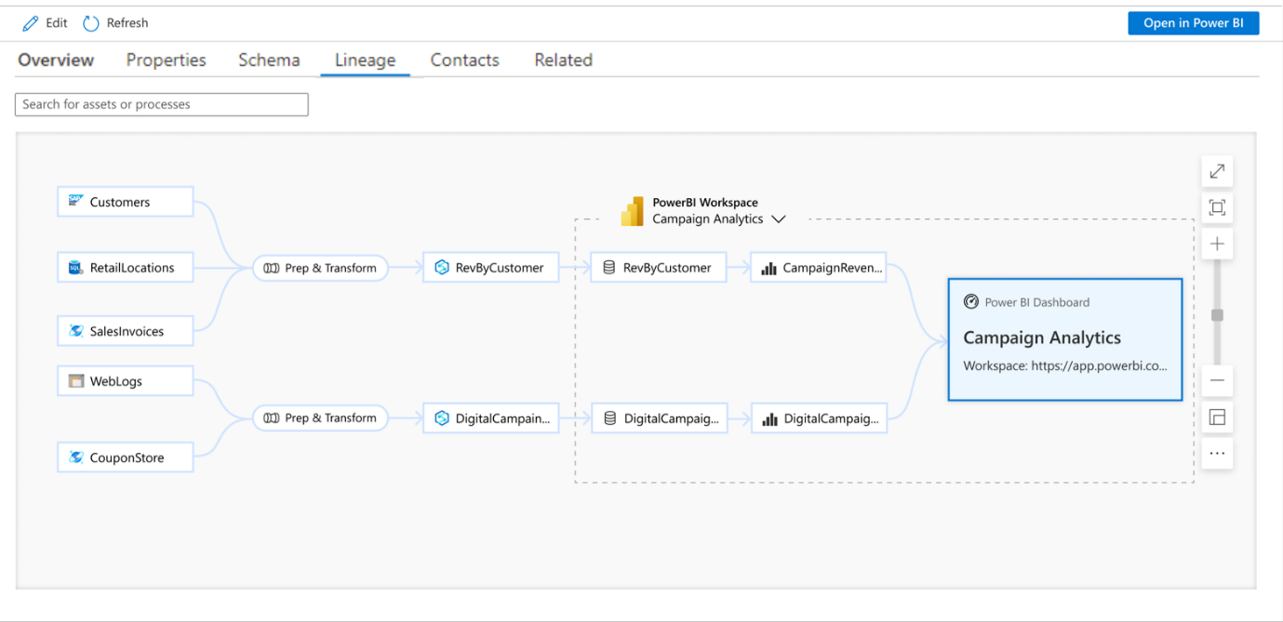

In the Purview Governance Portal, lineage is displayed from the asset you're currently viewing.

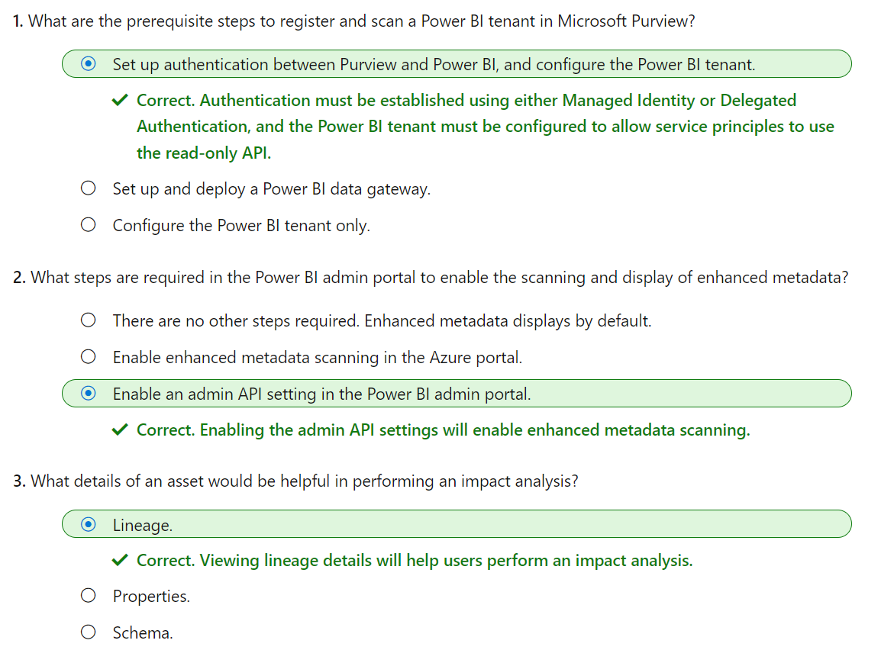

# Integrate Microsoft Purview and Azure Synapse Analytics

Learn how to integrate Microsoft Purview with Azure Synapse Analytics to improve data discoverability and lineage tracking.

## Learning objectives

After completing this module, you'll be able to:

* Catalog Azure Synapse Analytics database assets in Microsoft Purview.
* Configure Microsoft Purview integration in Azure Synapse Analytics.
* Search the Microsoft Purview catalog from Synapse Studio.
* Track data lineage in Azure Synapse Analytics pipelines activities.

Microsoft Purview is a cloud service that provides the basis of a *data governance* solution in which you can catalog, classify, and track data assets across a large-scale data estate.

Azure Synapse Analytics is a cloud-scale data analytics suite that supports data ingestion and transformation, distributed big data processing and exploration with SQL and Spark, and enterprise data warehousing.

When combined, Microsoft Purview and Azure Synapse Analytics can be used to create a comprehensive solution for reliable, massively scalable data analytics with rich data asset discovery and lineage tracking capabilities.

In this module you'll learn how to:

* Catalog Azure Synapse Analytics database assets in Microsoft Purview.
* Configure Microsoft Purview integration in Azure Synapse Analytics.
* Search the Microsoft Purview catalog from Synapse Studio.
* Track data lineage in Azure Synapse Analytics pipelines activities.

# Catalog Azure Synapse Analytics data assets in Microsoft Purview

Azure Synapse Analytics is a platform for cloud-scale analytics workloads that process data in multiple sources; including:

* Relational databases in serverless and dedicated SQL pools
* Files in Azure Data Lake Storage Gen2

A comprehensive data analytics solution can include many folders and files in a data lake, and multiple databases that each contain many tables, each with multiple fields. For a data analyst, finding and understanding the data assets associated with a Synapse Analytics workspace can present a significant challenge before any analysis or reporting can even begin.

Microsoft Purview can help in this scenario by cataloging the data assets in a data map, and enabling data stewards to add metadata, categorization, subject matter contact details, and other information that helps data analysts identify and understand data.

## Configure data access for Microsoft Purview

In order to scan the data assets in the data lake storage and databases used in your Azure Synapse Workspace, Microsoft Purview must have appropriate permissions to read the data. In practice, this means that the account used by your Microsoft Purview account (usually a system-assigned managed identity that is created when Microsoft Purview is provisioned) needs to be a member of the appropriate role-based access control (RBAC) and database roles.

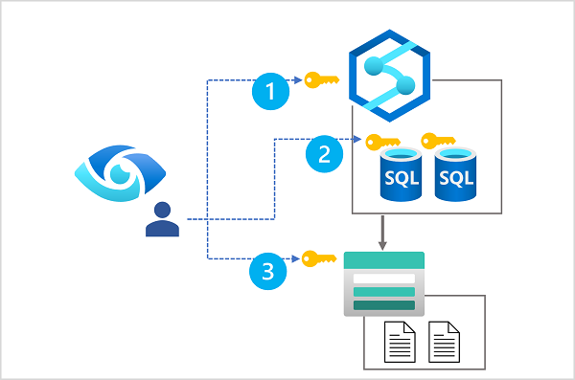

The diagram shows that Microsoft Purview requires role membership that permits the following access:

1. Read access to the Azure Synapse workspace (achieved through membership of the **Reader** role for the Azure Synapse Workspace resource in the Azure subscription).
2. Read access to each SQL database that will be scanned (achieved through membership of the **db_datareader** fixed database role in each database).
3. Read access to data lake storage (achieved through membership of the **Storage Blob Data Reader** role for the Azure Storage account hosting the Azure Data Lake Storage Gen2 container for the data lake).

**Tip**

Learn more:

* For more information about RBAC in Microsoft Azure, see [**What is Azure role-based access control (Azure RBAC)?**](https://learn.microsoft.com/en-us/azure/role-based-access-control/overview)
* For more information about database-level roles in Azure Synapse Analytics SQL pools, see [**Database-level roles**](https://learn.microsoft.com/en-us/sql/relational-databases/security/authentication-access/database-level-roles?azure-portal-true).

You'll get a chance to assign RBAC and SQL database role membership to support Microsoft Purview data access for yourself in the exercise later in this module.

## Register and scan data sources

Microsoft Purview supports the creation of a data map that catalogs data assets in collections by scanning registered sources. Collections form a hierarchy of logical groupings of related data assets, under a root collection that is created when you provision a Microsoft Purview account. You can use the Microsoft Purview Governance Portal to create and manage collections in your account.

To include assets from a particular data source, you need to register the source in a collection. Microsoft Purview supports many kinds of source, including:

* **Azure Synapse Analytics** - One or more SQL databases in a Synapse Analytics workspace.
* **Azure Data Lake Storage Gen2** - Blob containers used to host folders and files in a data lake.

To catalog assets used in an Azure Synapse Analytics workspace, you can register one or both of these sources in a collection, as shown here:

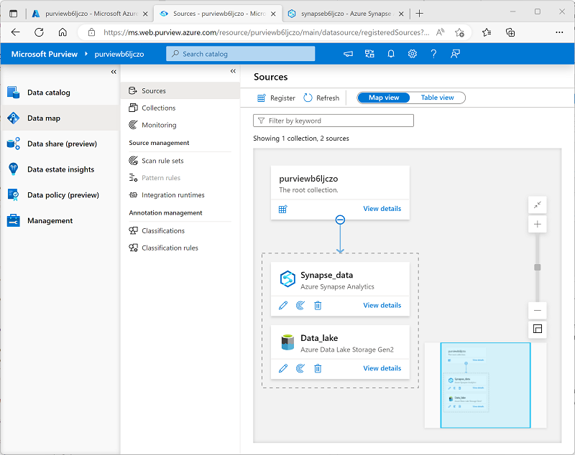

After registering the sources where your data assets are stored, you can scan each source to catalog the assets it contains. You can scan each source interactively, and you can schedule period scans to keep the data map up to date.

**Tip**

To learn more about registering and scanning sources, see [**Scans and ingestion in Microsoft Purview**](https://learn.microsoft.com/en-us/azure/purview/concept-scans-and-ingestion).

You'll get a chance to register and scan sources for an Azure Synapse Analytics workspace in the exercise later in this module.

## View and manage cataloged data assets

As each scan finds data assets in the registered sources, they're added to the associated collection in the data catalog. You can query the data catalog in the Microsoft Purview Governance Portal to view and filter the data assets, as shown here:

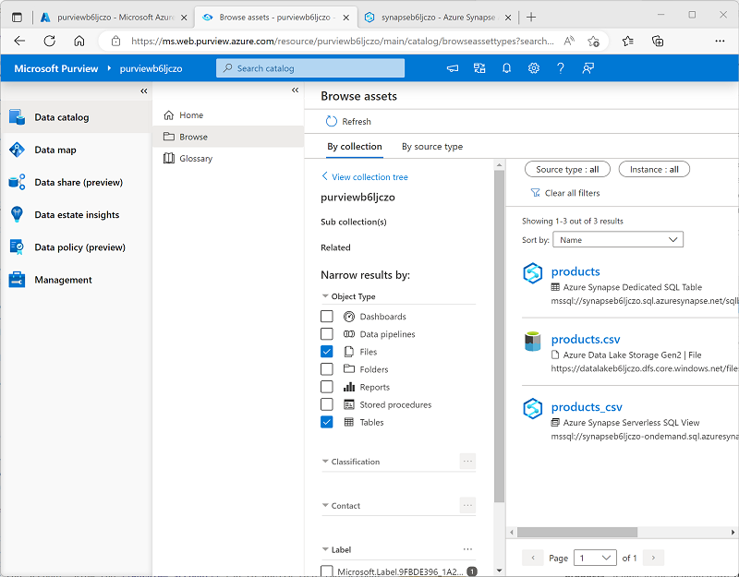

Data assets include items in the registered data stores at multiple levels. For example, assets from an Azure Synapse Analytics source include databases, schemas, tables, and individual fields; and assets from an Azure Data Lake Storage Gen 2 source include containers, folders, and files.

You can view and edit the properties of each asset to add contextual information such as descriptions, contacts for expert help, and other useful metadata. Data assets can also be classified using built-in or custom classifications that match specific patterns of data field to common types of data - for example, passport numbers, credit card numbers, and others.

**Tip**

To learn more about data asset classification, see [**Data classification in the Microsoft Purview governance portal**](https://learn.microsoft.com/en-us/azure/purview/concept-classification).

# Connect Azure purview to an Azure Synapse Analytics workspace

So far, you've learned how you can use Azure Synapse Analytics data stores as sources for a Microsoft Purview catalog; which is similar in most respects to using any other data source.

What sets Azure Synapse Analytics apart from many other data sources is the ability to configure direct integration between an Azure Synapse Analytics workspace and a Microsoft Purview account. By linking your workspace to a Purview account, you can:

* Search the Purview catalog in the Synapse Studio user interface.
* Push details of data pipeline activities to Purview in order to track data lineage information.

## Connect a Purview account to a Synapse Analytics workspace

You connect a Microsoft Purview account to an Azure Synapse Analytics workspace on the **Manage** page of Synapse Studio, as shown here:

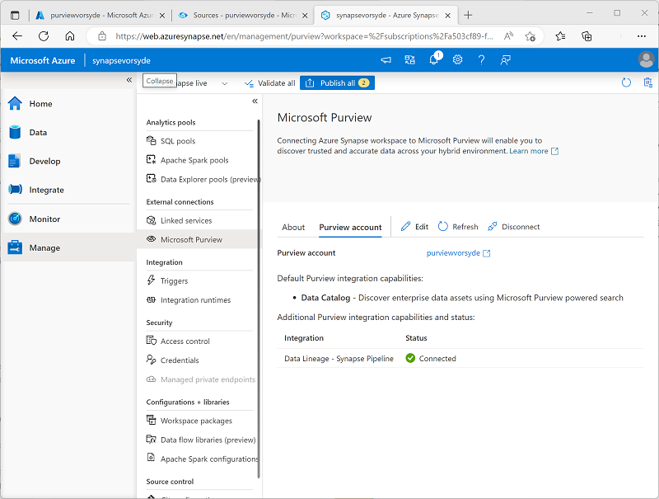

### Security considerations

To connect a Purview account by using the Synapse Studio interface, you require **Collection Administrator** access to the Purview account's root collection. After successfully connecting the account, the managed identity used by your Azure Synapse Analytics workspace will be added to the collection's **Data Curator** role.

If your Microsoft Purview account is behind a firewall, you need to create a managed endpoint, and configure the connection to access Purview using that endpoint. For more information, see [Access a secured Microsoft Purview account from Azure Synapse Analytics](https://learn.microsoft.com/en-us/azure/synapse-analytics/catalog-and-governance/how-to-access-secured-purview-account).

**Tip**

To learn more about connecting Azure Synapse Analytics to Microsoft Purview, see [**QuickStart: Connect a Synapse workspace to a Microsoft Purview account**](https://learn.microsoft.com/en-us/azure/synapse-analytics/catalog-and-governance/quickstart-connect-azure-purview).

You'll get a chance to connect an Azure Synapse Analytics workspace to a Microsoft Purview account in the exercise later in this module.

# Search a Purview catalog in Synapse Studio

After connecting an Azure Synapse Analytics workspace to a Microsoft Purview account, you can search the Purview catalog from Synapse Studio. This ability to discover and examine data assets from across the enterprise can greatly assist data engineers, data analysts, and other consumers of data by providing a curated catalog of documented data sources for analysis and reporting.

## Search the Purview catalog in Synapse Studio

You can search the catalog from a connected Purview account by using the **Search** bar in the **Data**, **Develop**, or **Integrate** pages in Synapse Studio, as shown here:

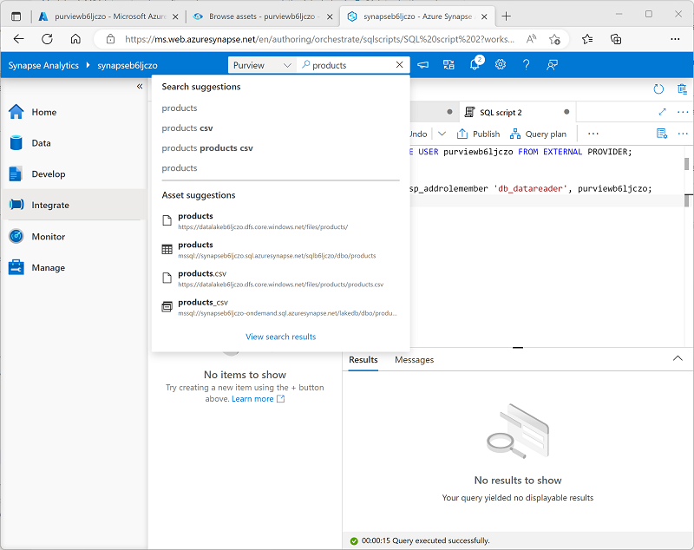

The search results interface, and the details for each asset found reflect the user interface in the Microsoft Purview Governance Portal, ensuring that the data discovery and examination experience in Synapse Studio is consistent for users of Microsoft Purview in its own portal.

**Tip**

For more information about searching the Purview catalog in Synapse Studio, see [**Discover, connect, and explore data in Synapse using Microsoft Purview**](https://learn.microsoft.com/en-us/azure/synapse-analytics/catalog-and-governance/how-to-discover-connect-analyze-azure-purview).

You'll get a chance to try searching a connected Purview account for yourself in the exercise later in this module.

# Track data lineage in pipelines

In a typical large-scale analytics solution, data is transferred and transformed across multiple systems until it's loaded into an analytical data store for reporting and analysis. Tracking the lineage of data as moves across the enterprise is an important factor in determining the provenance, trustworthiness, and recency of data assets used to inform analysis and decision making.

## Generate and view data lineage information

In Azure Synapse Analytics, data movement and transformation is managed by using pipelines, which consist of an orchestrated set of activities that operate on data. The design and implementation of pipelines is too large a subject to cover in depth in this module, but a key point to be aware of is that there are two activity types available in Synapse Analytics pipelines that automatically generate data linage information in a connected Purview catalog:

* The **Copy Data** activity
* The **Data Flow** activity

Running a pipeline that includes either of these activities in a workspace with a connected Purview account will result in the creation or update of data assets with lineage information. The assets recorded include:

* The source from which the data is extracted.
* The activity used to transfer the data.
* The destination where the data is stored.

In the Microsoft Purview Governance Portal, you can open the assets in the Purview catalog, and view the linage information as shown here:

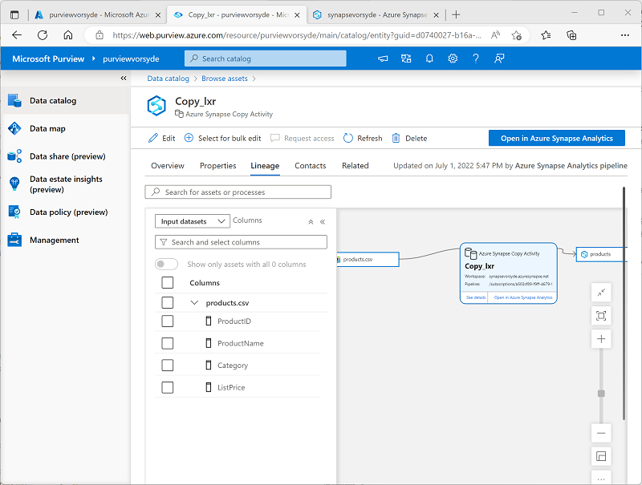

You can also view the linage for a pipeline activity in Synapse Studio.

**Tip**

For more information about tracking data lineage for Azure Synapse Analytics pipelines in Microsoft Purview, see [**How to get lineage from Azure Synapse Analytics into Microsoft Purview**](https://learn.microsoft.com/en-us/azure/purview/how-to-lineage-azure-synapse-analytics).

You'll get a chance to generate and view data lineage from a Synapse Analytics pipeline in the exercise later in this module.

# Exercise - Integrate Azure Synapse Analytics and Microsoft Purview

Now it's your chance to explore integration between Microsoft Purview and Azure Synapse Analytics for yourself. In this exercise, you'll use a provided script to provision an Azure Synapse Analytics workspace and a Microsoft Purview account in your Azure subscription; and then you'll catalog data assets in your Azure Synapse Analytics workspace and data lake before connecting the Purview account to the workspace to support data discovery and lineage tracking.

**Note**

To complete this lab, you will need an [**Azure subscription**](https://azure.microsoft.com/free) in which you have administrative access.

<https://microsoftlearning.github.io/dp-203-azure-data-engineer/Instructions/Labs/22-Synapse-purview.html>

